FOCUSED USE CASE

Shared Business Rules (References)
- BR-STAT-01: Order statuses: Placed → Confirmed → Preparing → Ready → Completed; plus Cancelled.
- BR-STAT-02: Block invalid transitions (e.g., Ready → Preparing).
- BR-CAN-01: Customer can cancel only when status = Placed.
- BR-CAN-02: Restaurant can reject/cancel before Ready; reason required. After Ready, cancellation is restricted (optional).
- BR-SLOT-01: Pickup slots generated from opening hours + interval; no past slots.
- BR-SLOT-02: Optional capacity cap per slot; full slots are unavailable.
- BR-AVAIL-01: Re-validate item availability at checkout submit; if any item becomes unavailable → block submit and list impacted items.
- BR-PRICE-01: Total = Σ(priceSnapshot × qty); snapshot captured at order creation; later price changes do not affect historical orders.
- BR-RBAC-01: Roles: Owner/Admin (full) vs Cashier/Operator (orders + limited menu availability toggle).
- BR-AUD-01: All status changes must log fromStatus/toStatus/changedBy/changedAt.
- BR-CONC-01: Concurrency conflict (two operators) → only one succeeds; other sees “status already updated”.
- BR-SEC-01: Dashboard requires authentication; restrict customer phone visibility by role as needed.
- BR-PERF-01: Order queue refresh ≤ 10 seconds (MVP acceptable).

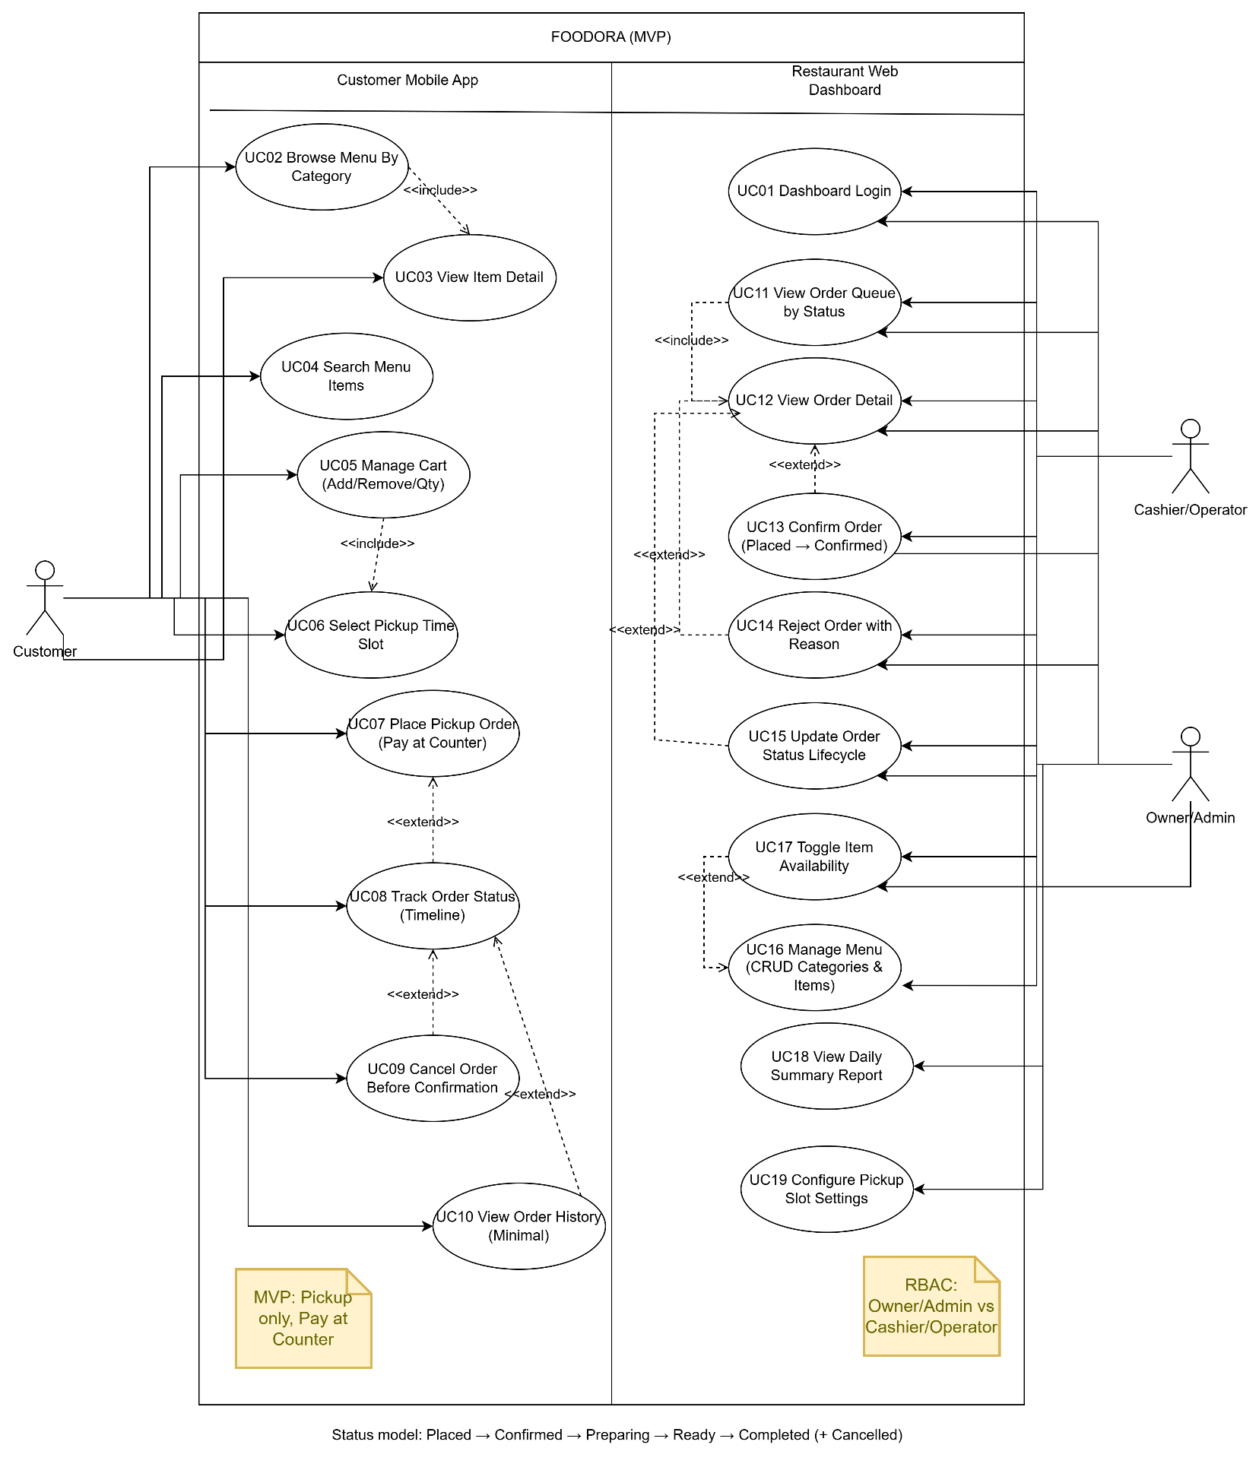
UC01 — Dashboard Login (Auth & Roles)

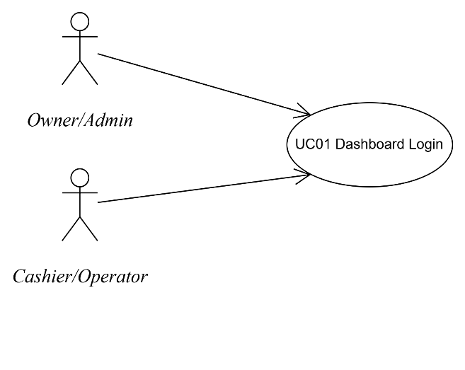
Use Case Number: | UC01
Use Case Name: | Restaurant Dashboard Login
Actor (s): | Owner/Admin, Cashier/Operator
Maturity: | Focused
Summary: | Staff authenticate to access dashboard features based on role (orders/menu/reports).
Basic Course of Events: | Actor Action | System Response
Basic Course of Events: | 1. Staff authenticate to access dashboard features based on role (orders/menu/reports).
Basic Course of Events: |  | 2. System displays the login page (username/email, password, Login button).
Basic Course of Events: | 3. Actor enters username/email and password.
Basic Course of Events: | 4. Actor clicks “Login”. A1, E1, E2, E3
Basic Course of Events: |  | 5. System authenticates credentials, creates session, loads role/permissions.
Basic Course of Events: |  | 6. System routes user to landing page (Cashier → Order Queue; Admin → Orders/Menu/Reports). A2
Basic Course of Events: | 7. Actor views the dashboard landing page. The use case ends here.
Alternative Paths: | A1. Forgot Password  From step 4 of the Basic Course of Events, the actor may select “Forgot password”. The system displays password reset instructions (portfolio-level). After completion, the actor is returned to the login page. Control returns to step 2.
Alternative Paths: | A2. Multiple-role user selects role  From step 6, if the actor has multiple roles, the system prompts the actor to select a role. After the role is selected, the system routes to the corresponding landing page. The use case continues. Control returns to step 7.
Exception Paths: | E1. Invalid credentials  If the actor enters an incorrect username/password, the system displays an error message and requests the actor to re-enter credentials. Control returns to step 3.
Exception Paths: | E2. Account disabled/locked  If the actor’s account is disabled/locked, the system denies access and displays the account status message. Control returns to step 2.
Exception Paths: | E3. System error/timeout  If authentication fails due to a system error/timeout, the system displays “Try again later” and logs the error. Control returns to step 2.
Extension Points: | Two-factor authentication (2FA/OTP) (Future)
Triggers: | Staff needs to access dashboard to process orders or manage menu.
Assumptions: | User accounts are provisioned by Owner/Admin.
Preconditions: | Dashboard is available; user has valid credentials.
Post Conditions: | User is authenticated; session is created; user lands on role-appropriate page.
Reference: Business Rules | BR-RBAC-01, BR-SEC-01
Author(s): | Business Analyst
Date: | 2026-01-07
Activity Diagram:
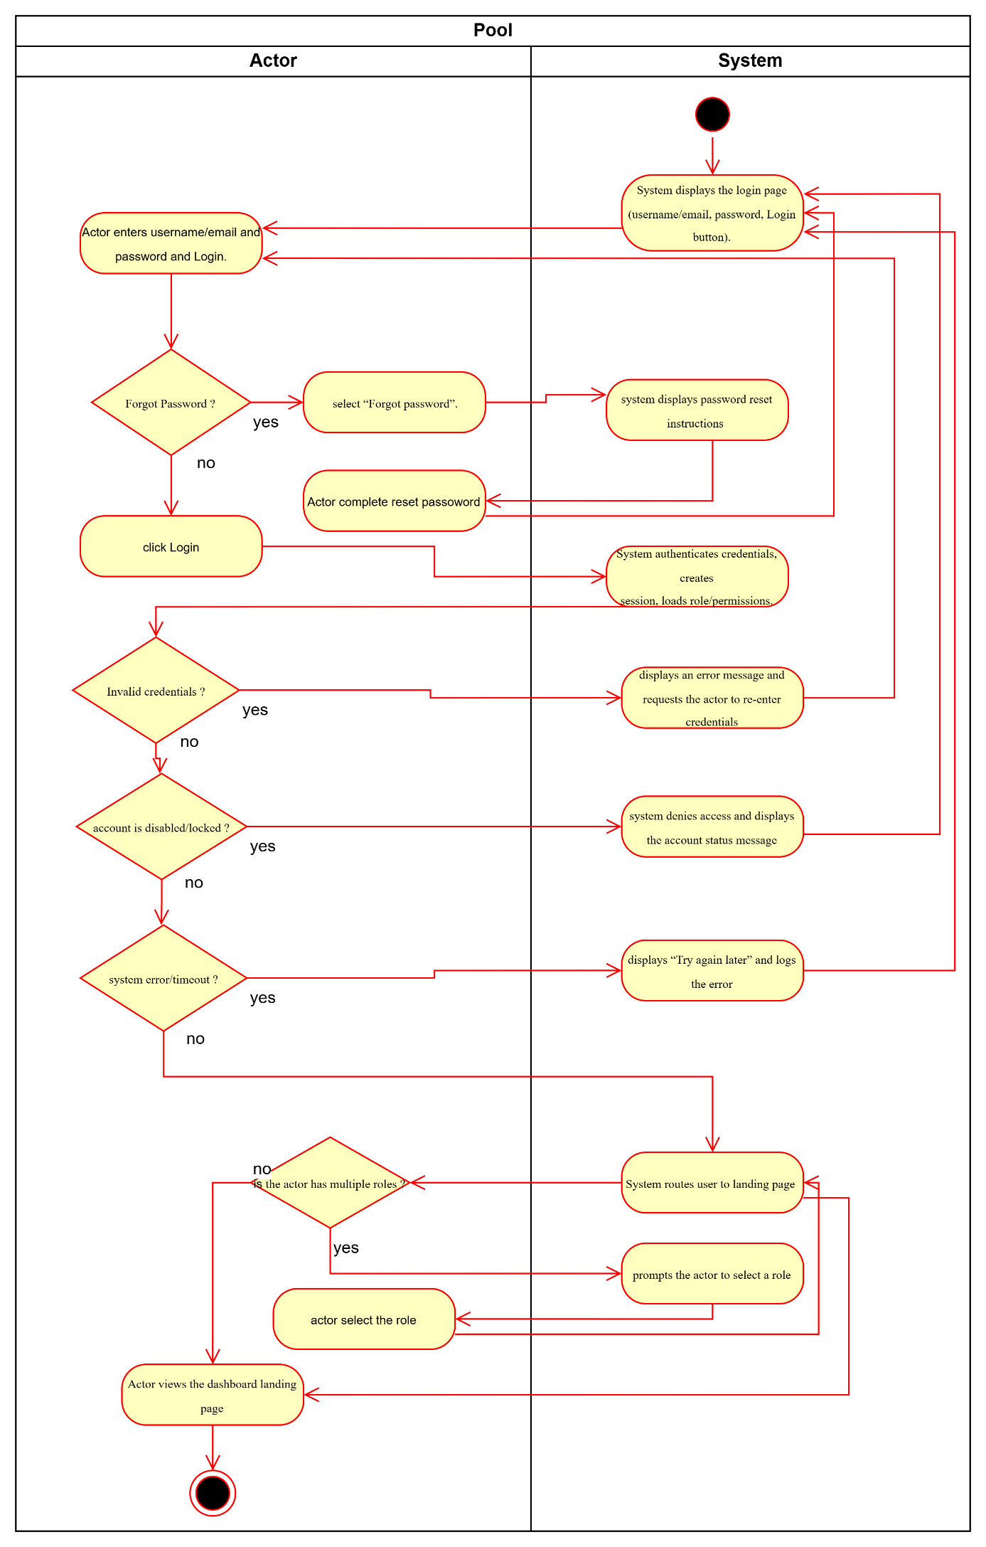

UC02- Browse Menu by Category

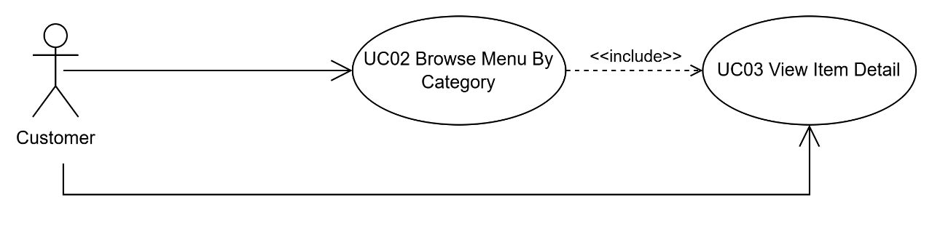
Use Case Number: | UC02
Use Case Name: | Browse Menu by Category
Actor (s): | Customer
Maturity: | Focused
Summary: | Customer browses categories/items and sees availability.
Basic Course of Events: | Actor Action | System Response
Basic Course of Events: | 1. Customer opens the app and navigates to the restaurant menu.
Basic Course of Events: |  | 2. System displays categories and items (name, price, availability). E1
Basic Course of Events: | 3. Customer selects a category.
Basic Course of Events: |  | 4. System displays items for the selected category. A1
Basic Course of Events: | 5. Customer selects an item.
Basic Course of Events: |  | 6. System opens item detail. (See UC03)
Basic Course of Events: | 7. Customer continues browsing or proceeds to cart. The use case ends here.
Alternative Paths: | A1. Category has no items  From step 4, if the selected category contains no items, the system displays an empty state (“No items”). The customer may select a different category. Control returns to step 3.
Exception Paths: | E1. Menu load failure  If the system cannot load categories/items, it displays an error state with Retry. After retry, the system re-attempts loading. Control returns to step 2.
Extension Points: | Sorting/filtering (Future)
Triggers: | Customer wants to browse menu to place a pickup order.
Assumptions: | Menu categories/items are already configured by restaurant staff.
Preconditions: | Restaurant and menu exist; customer can access the app.
Post Conditions: | Customer can view categories/items and navigate to item detail.
Reference: Business Rules | BR-AVAIL-01
Author(s): | Business Analyst
Date: | 2026-01-07
Activity Diagram:
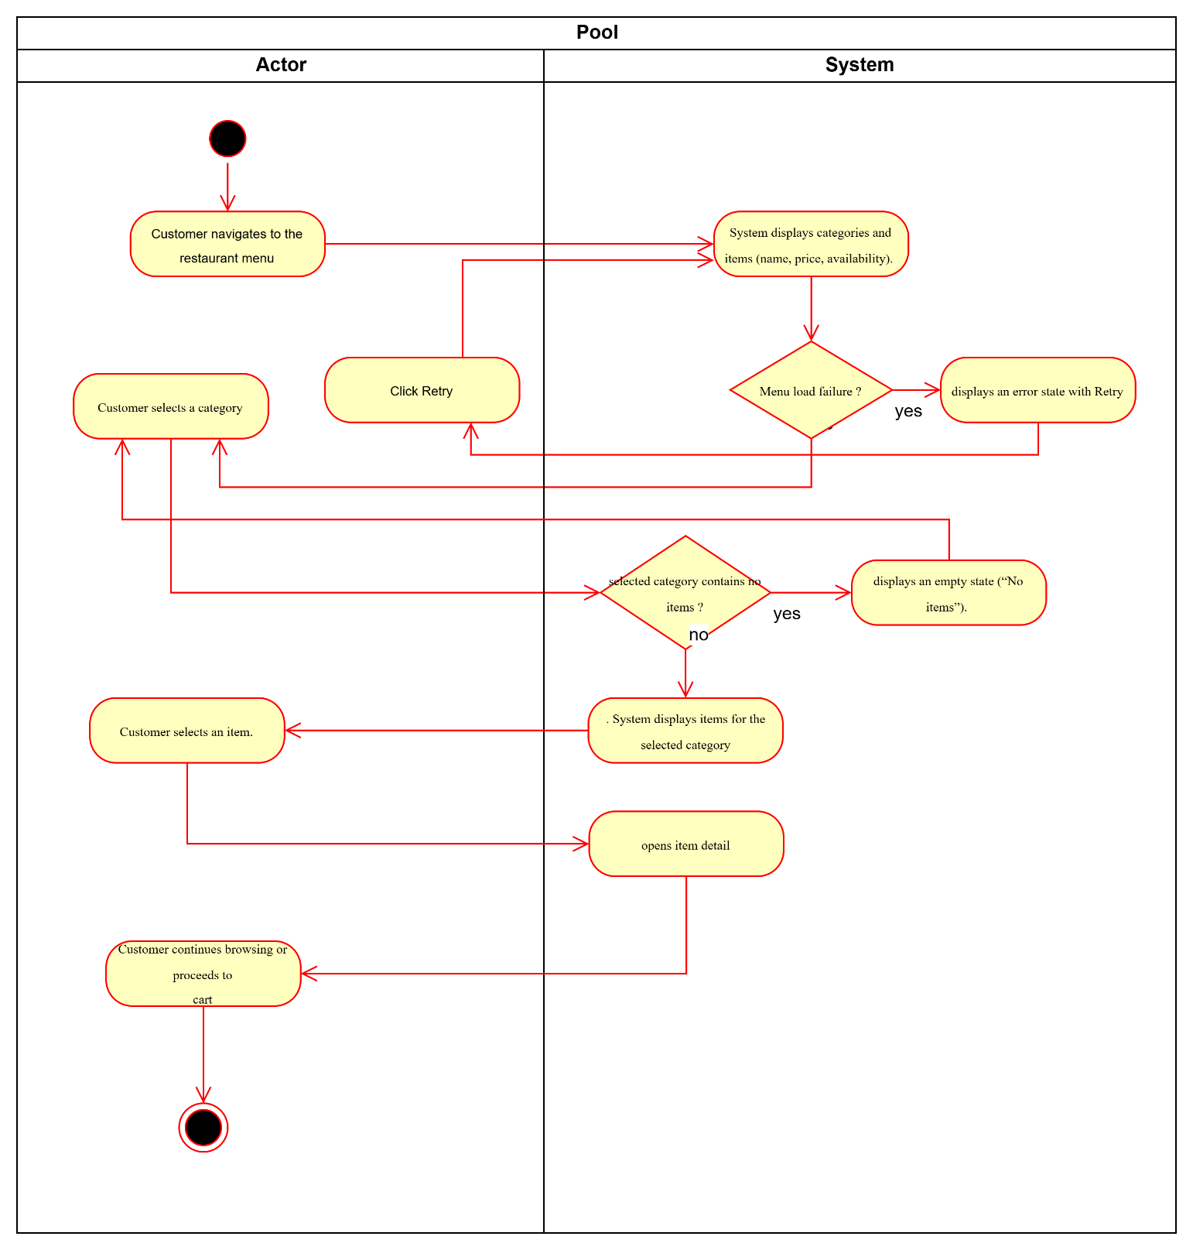

UC03- View Item Detail

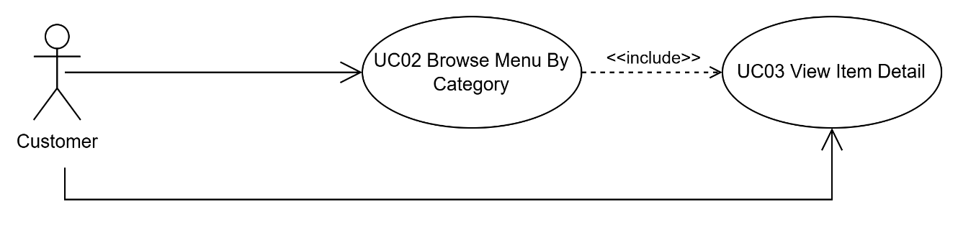
Use Case Number: | UC03
Use Case Name: | View Item Detail
Actor (s): | Customer
Maturity: | Focused
Summary: | Customer views item details and adds available items to cart.
Basic Course of Events: | Actor Action | System Response
Basic Course of Events: | 1. Customer selects an item from the menu list.
Basic Course of Events: |  | 2. System displays item detail (name, price, availability, description/image if available). E1
Basic Course of Events: | 3. Customer optionally enters item note/instructions.
Basic Course of Events: | 4. Customer clicks “Add to cart”. A1
Basic Course of Events: |  | 5. System adds item to cart and updates cart totals/badge.
Basic Course of Events: | 6. Customer continues browsing or opens cart. The use case ends here.
Alternative Paths: | A1. Item is unavailable  From step 4, if the item is unavailable, the system disables “Add to cart” and displays “Out of stock”. Control returns to step 2.
Exception Paths: | E1. Item detail load failure  If the system cannot load the item detail, it displays an error state with Retry. Control returns to step 2.
Extension Points: | None
Triggers: | Customer selects an item from the menu list.
Assumptions: | Item availability displayed may change during peak hours.
Preconditions: | Menu is available; item exists.
Post Conditions: | Item detail is displayed; item may be added to cart if available.
Reference: Business Rules | BR-AVAIL-01
Author(s): | Business Analyst
Date: | 2026-01-07
Activity Diagram:
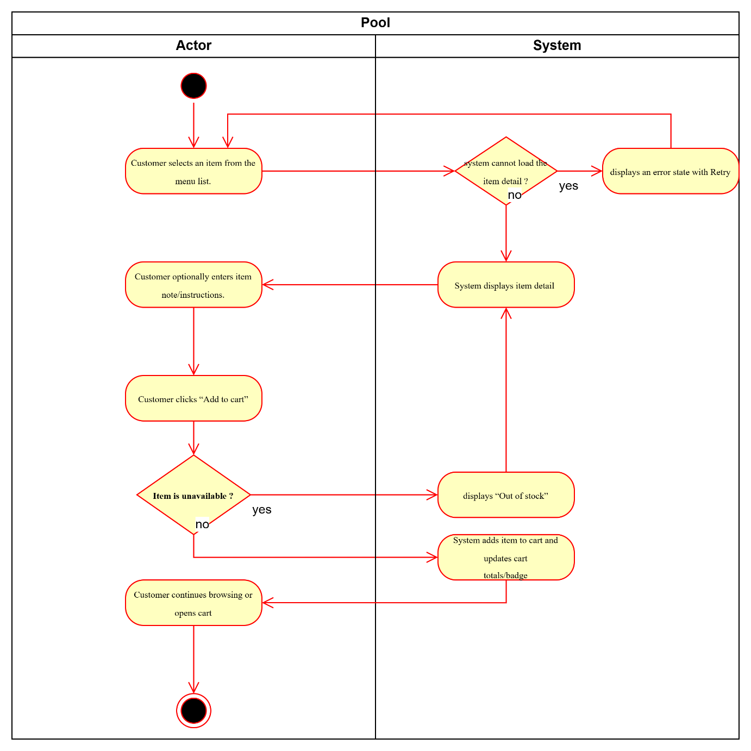

UC04- Search Menu Items

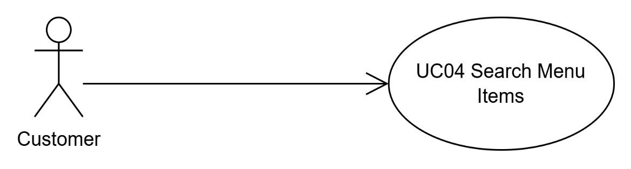
Use Case Number: | UC04
Use Case Name: | Search Menu Items
Actor (s): | Customer
Maturity: | Focused
Summary: | Customer searches items by keyword.
Basic Course of Events: | Actor Action | System Response
Basic Course of Events: | 1. Customer opens search from the menu page.
Basic Course of Events: |  | 2. System displays a keyword input field.
Basic Course of Events: | 3. Customer enters a keyword and submits. A1
Basic Course of Events: |  | 4. System displays matching items. E1, E2
Basic Course of Events: | 5. Customer selects an item from results.
Basic Course of Events: |  | 6. System opens item detail (UC03).
Basic Course of Events: | 7. Customer exits search. The use case ends here.
Alternative Paths: | A1. Empty keyword (paragraph style)  From step 3, if the keyword is empty, the system shows a guidance message and does not run search. Control returns to step 2.
Exception Paths: | E1. No results  If no items match the keyword, the system displays “No results”. Control returns to step 2.
Exception Paths: | E2. Search error  If search fails, the system displays an error state with Retry. Control returns to step 4.
Extension Points: | Autocomplete/suggestions (Future)
Triggers: | Customer wants to find items faster by keyword.
Assumptions: | Search is a “Should” feature; minimal implementation acceptable in MVP.
Preconditions: | Menu data is available to search.
Post Conditions: | Matching results or “No results” state is displayed.
Reference: Business Rules | None
Author(s): | Business Analyst
Date: | 2026-01-07
Activity Diagram:
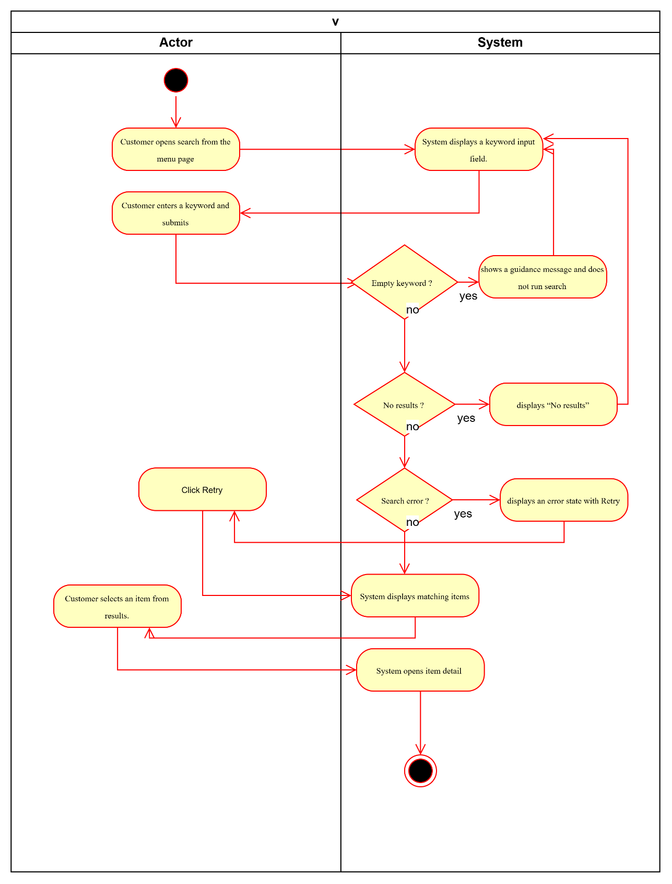

UC05- Manage Cart (Add/Remove/Update Quantity)

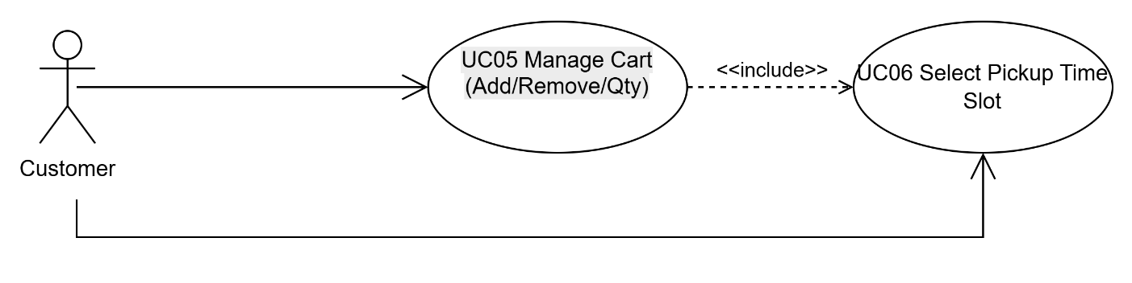
Use Case Number: | UC05
Use Case Name: | Manage Cart (Add/Remove/Update Quantity)
Actor (s): | Customer
Maturity: | Focused
Summary: | Customer updates quantities/removes items and proceeds to checkout.
Basic Course of Events: | Actor Action | System Response
Basic Course of Events: | 1. Customer opens the Cart screen.
Basic Course of Events: |  | 2. System displays cart items, quantity controls, subtotal and total. E1
Basic Course of Events: | 3. Customer increases/decreases quantity. A1
Basic Course of Events: |  | 4. System updates totals immediately; if quantity becomes 0, system removes the item.
Basic Course of Events: | 5. Customer clicks “Checkout”.
Basic Course of Events: |  | 6. System opens pickup time selection/checkout (UC06).
Basic Course of Events: | 7. Customer proceeds or exits. The use case ends here.
Alternative Paths: | A1. Remove item directly  From step 3, the customer may remove an item instead of changing quantity. The system removes the item and recalculates totals. Control returns to step 2.
Exception Paths: | E1. Cart is empty  If the cart is empty, the system displays an empty state and prompts the customer to browse menu. Control returns to step 1.
Extension Points: | Save cart for later (Future)
Triggers: | Customer wants to review/edit cart before checkout.
Assumptions: | Totals update immediately when quantities change.
Preconditions: | Customer can access cart (cart may be empty or non-empty).
Post Conditions: | Cart contents and totals reflect latest customer edits; customer can proceed to checkout.
Reference: Business Rules | BR-AVAIL-01, BR-PRICE-01
Author(s): | Business Analyst
Date: | 2026-01-07
Activity Diagram:
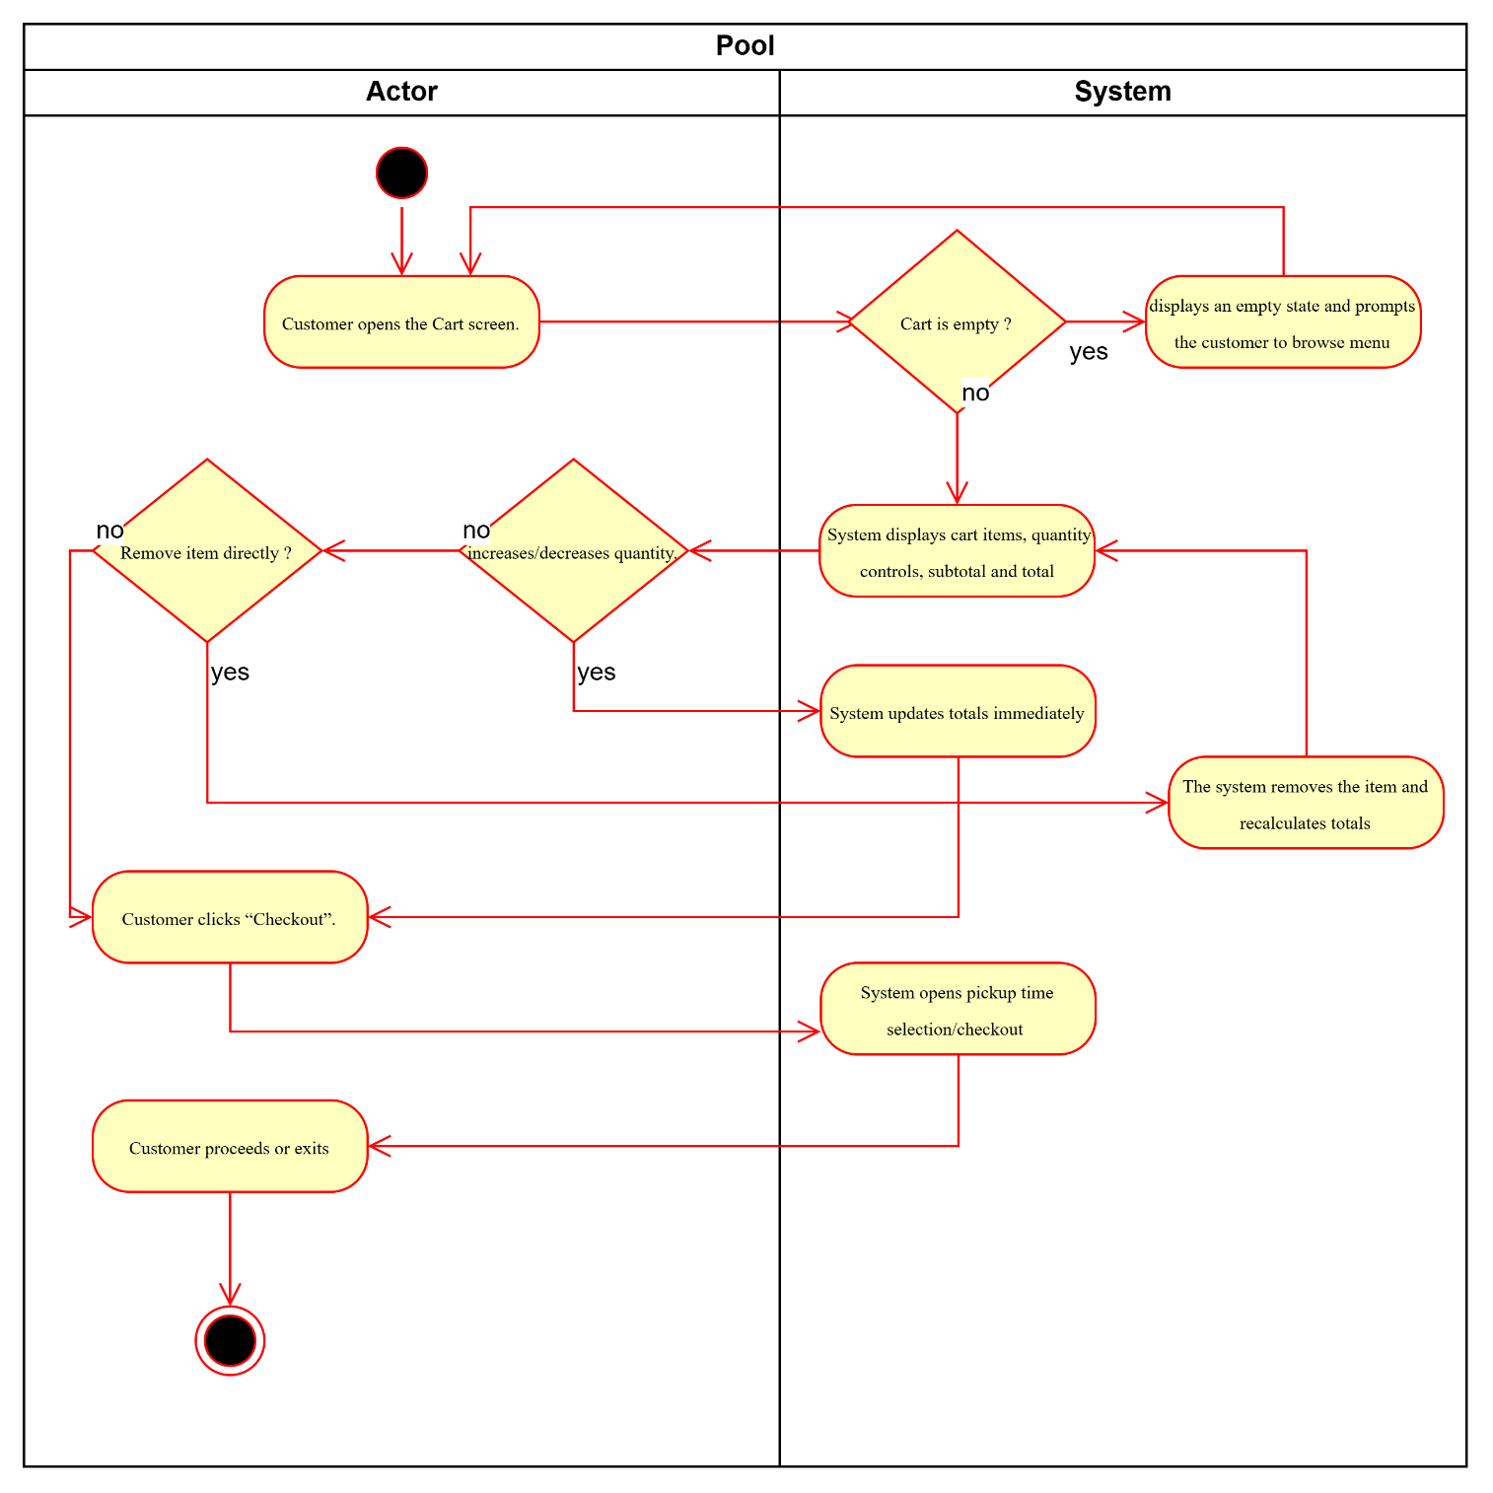

UC06- Select Pickup Time Slot
Use Case Number: | UC06
Use Case Name: | Select Pickup Time Slot
Actor (s): | Customer
Maturity: | Focused
Summary: | Customer selects a valid pickup time slot based on opening hours and interval (capacity optional).
Basic Course of Events: | Actor Action | System Response
Basic Course of Events: | 1. Customer opens “Pickup Time Selection”.
Basic Course of Events: |  | 2. System displays available pickup time slots. E1
Basic Course of Events: | 3. Customer selects a slot. E2, E3
Basic Course of Events: |  | 4. System saves the selected slot and returns to checkout summary.
Basic Course of Events: | 5. Customer confirms selection and continues checkout. The use case ends here. A1
Alternative Paths: | A1. Customer changes pickup time  From step 5, the customer may reopen pickup time selection and choose another slot. The system replaces the previous selection and updates checkout. Control returns to step 1.
Exception Paths: | E1. Slot list cannot be loaded  If the system cannot load slots, it displays an error state with Retry. Control returns to step 2.
Exception Paths: | E2. Slot is unavailable/full  If the selected slot is full/unavailable, the system blocks selection and displays an explanation. Control returns to step 2.
Exception Paths: | E3. Slot is invalid (past/out-of-hours)  If the slot is invalid, the system blocks selection and displays an explanation. Control returns to step 2.
Extension Points: | - Capacity cap per slot (Optional)  - Estimated ready time (Future)
Triggers: | Customer proceeds to checkout and must select a pickup time.
Assumptions: | Restaurant opening hours and slot interval are configured.
Preconditions: | Cart is not empty; slot generation rules exist.
Post Conditions: | A valid pickup slot is selected and shown in checkout summary.
Reference: Business Rules | BR-SLOT-01, BR-SLOT-02
Author(s): | Business Analyst
Date: | 2026-01-07
Activity Diagram:
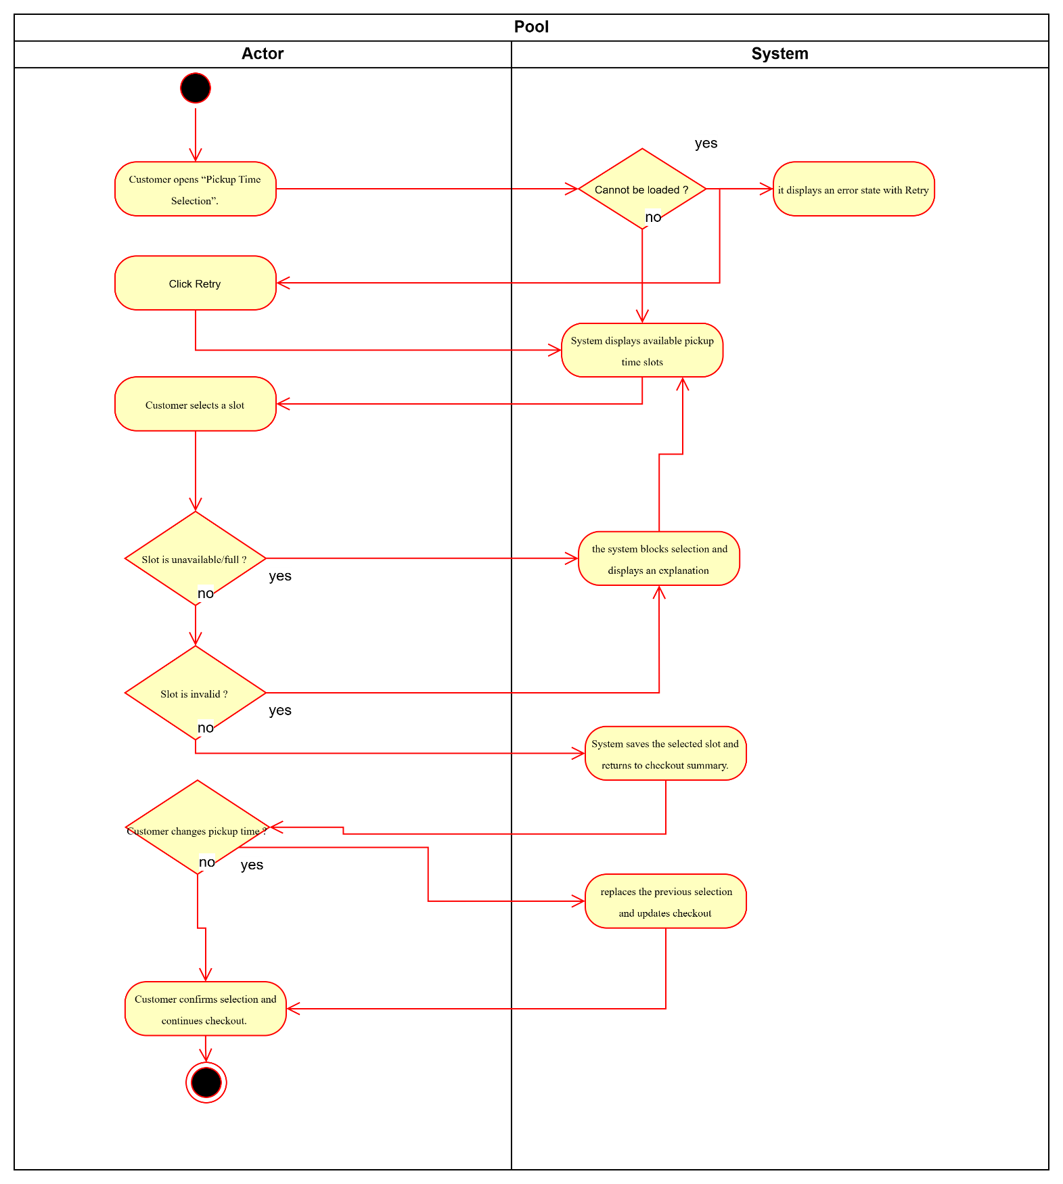

UC07- Place Pickup Order (Pay at Counter)

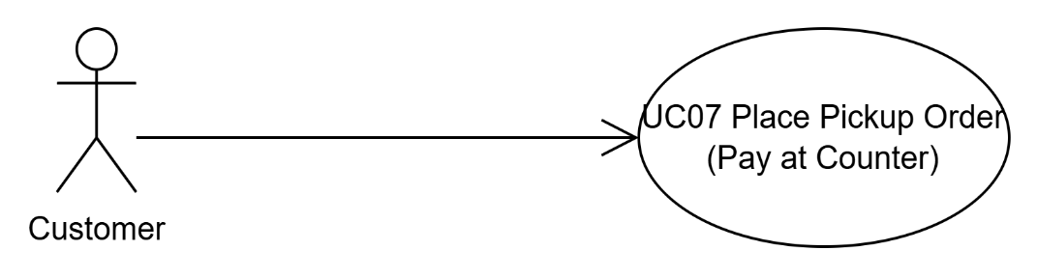
Use Case Number: | UC07
Use Case Name: | Place Pickup Order (Pay at Counter)
Actor (s): | Customer
Maturity: | Focused
Summary: | Customer places a pickup order; system creates an Order ID with status Placed.
Basic Course of Events: | Actor Action | System Response
Basic Course of Events: | 1. Customer reviews checkout summary (items, total, pickup time).
Basic Course of Events: | 2. Customer enters phone number (name/note optional). E1
Basic Course of Events: | 3. Customer clicks “Place Order”. A1
Basic Course of Events: |  | 4. System validates required inputs (cart not empty, pickup time selected, phone present).
Basic Course of Events: |  | 5. System re-validates item availability and slot availability at submission time. E2, E3
Basic Course of Events: |  | 6. System creates Order + OrderItems (captures price snapshots) and returns Order ID; status becomes Placed. E4
Basic Course of Events: |  | 7. System displays Order Confirmation and provides link to Order Tracking.
Basic Course of Events: | 8. Customer views confirmation. The use case ends here.
Alternative Paths: | A1. Edit Cart Before Submitting
Alternative Paths: | Actor Action | System Response
Alternative Paths: | 3. Customer clicks “Back to Cart” instead of placing the order.
Alternative Paths: |  | 4. System navigates to Cart (UC05).
Alternative Paths: | 5. Customer updates quantities/removes items.
Alternative Paths: |  | 6. System updates totals.
Alternative Paths: | 7. Customer proceeds to Checkout again.
Alternative Paths: |  | 8. System returns to checkout summary. Control returns to Basic step 1.
Exception Paths: | E1. Missing/invalid phone or missing required input  If the customer leaves phone missing or enters an invalid phone format, the system shows a validation message and blocks submission. Control returns to step 2.
Exception Paths: | E2. Item becomes unavailable during submit  If any item becomes unavailable at submission time, the system does not create the order, highlights impacted items, and requests cart update. Control returns to step 1.
Exception Paths: | E3. Pickup slot becomes unavailable/full during submit  If the selected pickup slot becomes unavailable/full at submission time, the system blocks creation and requests the customer to select another slot. Control returns to step 1 (then customer re-enters pickup selection per UC06).
Exception Paths: | E4. Timeout/server error (prevent duplicate orders)  If the system fails to create the order due to timeout/server error, it displays an error and prevents duplicate order creation on retry (idempotent behavior). Control returns to step 3.
Extension Points: | - Guest checkout vs account-based ordering (Future)  - Push notifications (Optional later)
Triggers: | Customer clicks “Place Order” in checkout.
Assumptions: | MVP payment mode is Pay at Counter; system supports price snapshots at order creation.
Preconditions: | Cart not empty; pickup time selected; phone provided; system available.
Post Conditions: | Order is created with Order ID and status Placed; confirmation is displayed; order is visible to restaurant dashboard.
Reference: Business Rules | BR-AVAIL-01, BR-SLOT-01, BR-PRICE-01, BR-STAT-01
Author(s): | Business Analyst
Date: | 2026-01-07
Activity Diagram:
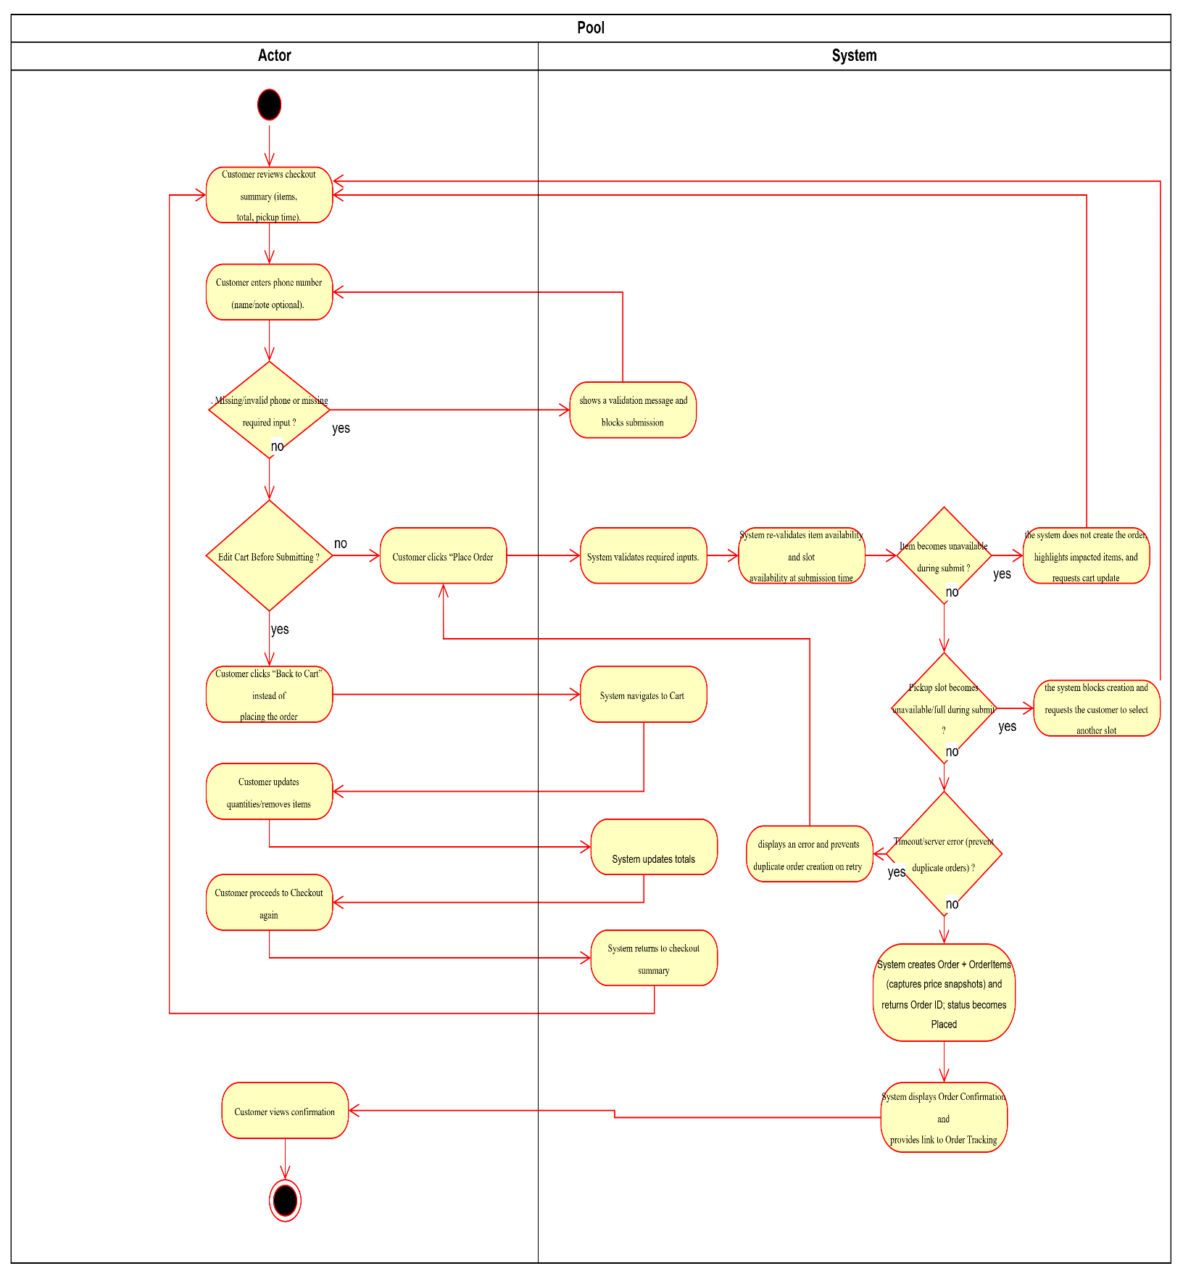

UC08- Track Order Status (Timeline)

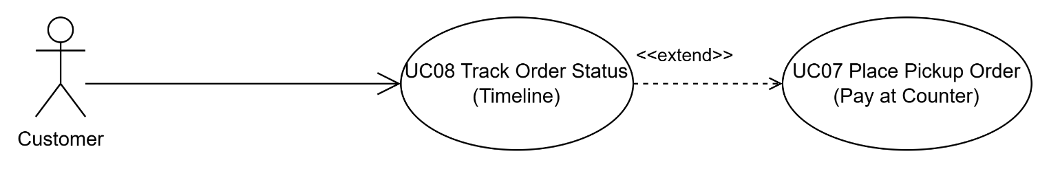
Use Case Number: | UC08
Use Case Name: | Track Order Status (Timeline)
Actor (s): | Customer
Maturity: | Focused
Summary: | Customer tracks order status timeline and timestamps.
Basic Course of Events: | Actor Action | System Response
Basic Course of Events: | 1. Customer opens Order Tracking for an order.
Basic Course of Events: |  | 2. System displays current status and status definitions.
Basic Course of Events: | 3. Customer refreshes tracking.A1
Basic Course of Events: |  | 4. System fetches latest status and shows “Last updated”.E1
Basic Course of Events: | 5. Customer sees status updates and exits. The use case ends here.
Alternative Paths: | A1. View timestamps (paragraph style)  From step 2, the customer may view timestamps (confirmedAt/readyAt/completedAt) when available. After viewing, the use case continues. Control returns to step 4.
Exception Paths: | E1. Cannot refresh / network stale  If the system cannot refresh status, it shows last known status and an offline/stale message with Retry. Control returns to step 3.
Extension Points: | Push notification on Ready (Future/Optional)
Triggers: | Customer wants to know when to pick up the order.
Assumptions: | Restaurant staff update statuses via dashboard; customer may need manual refresh in MVP.
Preconditions: | Order exists and is accessible for tracking.
Post Conditions: | Customer sees the latest known status timeline and definitions.
Reference: Business Rules | BR-STAT-01, BR-PERF-01
Author(s): | Business Analyst
Date: | 2026-01-07
Activity Diagram:
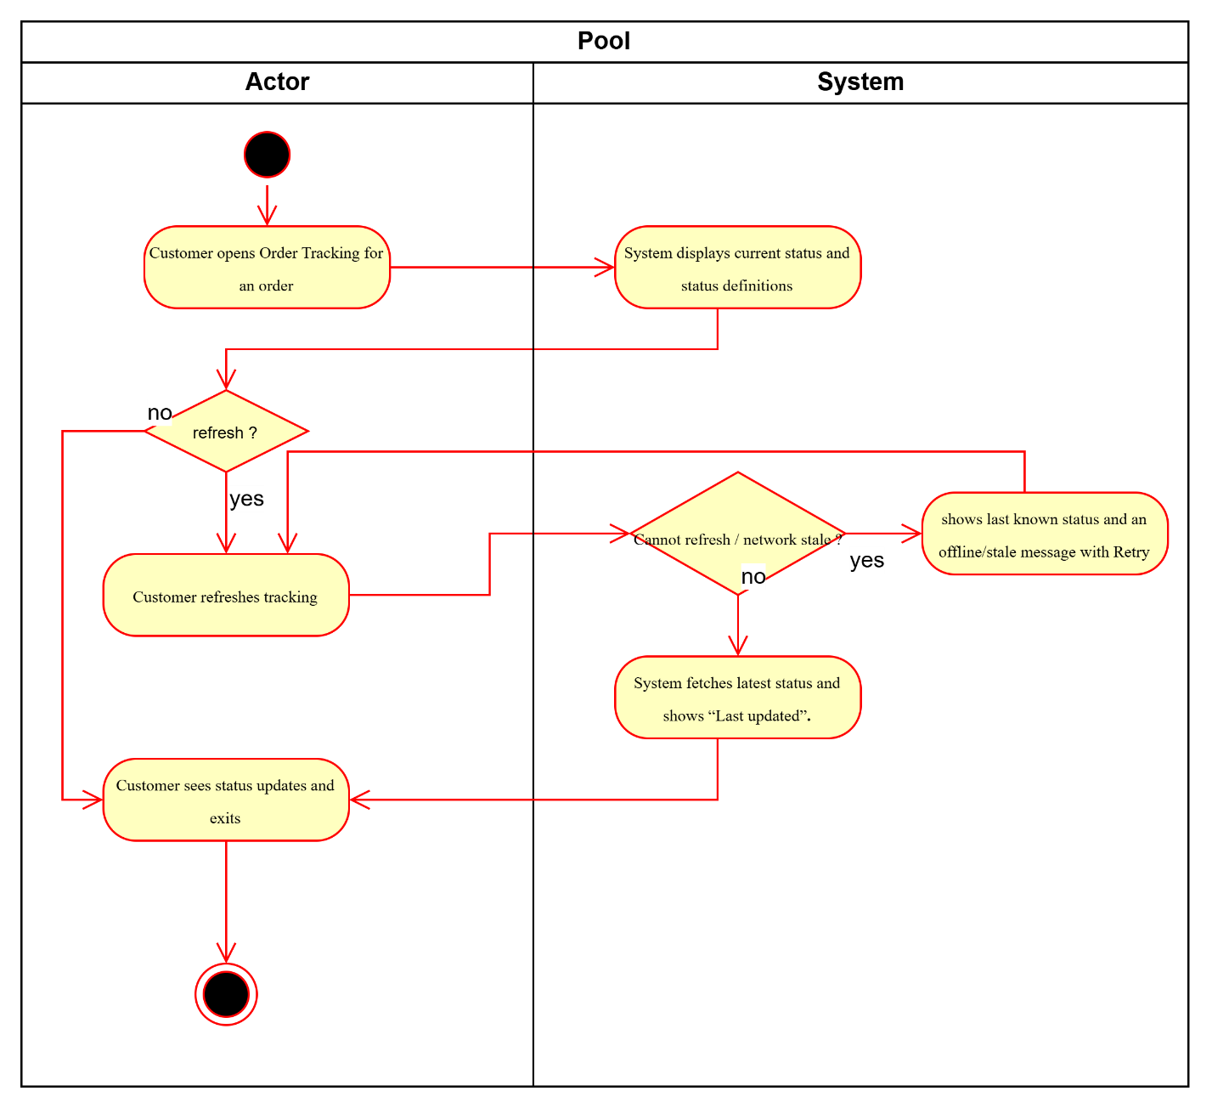

UC09- Cancel Order Before Confirmation

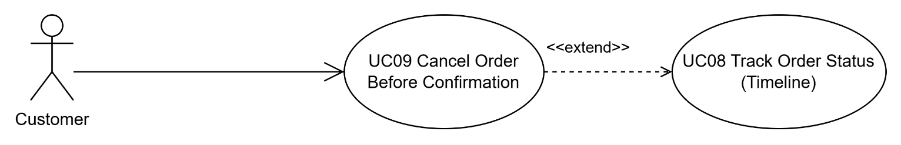
Use Case Number: | UC09
Use Case Name: | Cancel Order Before Confirmation
Actor (s): | Customer
Maturity: | Focused
Summary: | Customer cancels an order only when status is Placed.
Basic Course of Events: | Actor Action | System Response
Basic Course of Events: | 1. Customer opens order detail while status = Placed.
Basic Course of Events: |  | 2. System displays “Cancel order”. E1
Basic Course of Events: | 3. Customer clicks “Cancel” and confirms. E2
Basic Course of Events: |  | 4. System transitions order to Cancelled and records cancelledAt.
Basic Course of Events: |  | 5. System updates dashboard queue/history accordingly.
Basic Course of Events: | 6. Customer exits. The use case ends here.
Alternative Paths: | None
Exception Paths: | E1. Status is not Placed  If the order status is Confirmed/Preparing/Ready/Completed, the system disables cancellation and explains cancellation is only allowed before confirmation. Control returns to step 1.
Exception Paths: | E2. Status changed during cancellation (concurrency)  If the status changes before the cancellation is saved, the system blocks cancellation and shows “Status already updated”. Control returns to step 1.
Extension Points: | Customer cancellation reason (Optional)
Triggers: | Customer decides to cancel before restaurant confirmation.
Assumptions: | Cancellation is allowed only while status = Placed.
Preconditions: | Order exists; order status is Placed.
Post Conditions: | Order status becomes Cancelled; dashboard reflects cancellation; customer sees cancellation result.
Reference: Business Rules | BR-CAN-01, BR-CONC-01, BR-STAT-01
Author(s): | Business Analyst
Date: | 2026-01-07
Activity Diagram:
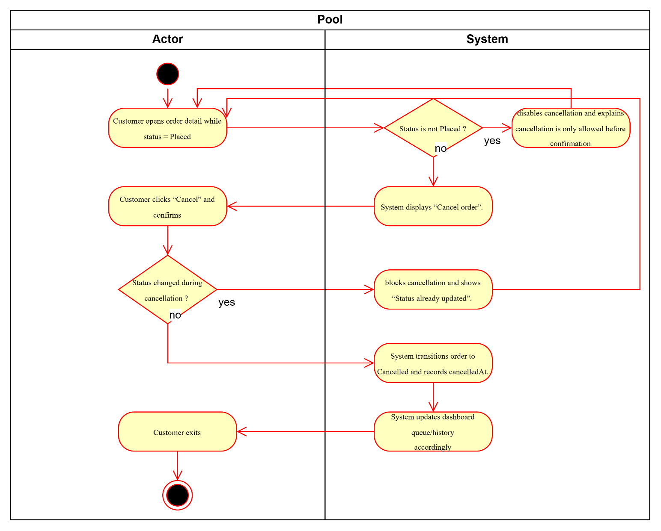

UC10- View Order History (Minimal)

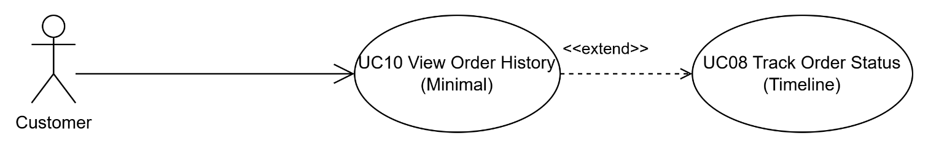
Use Case Number: | UC10
Use Case Name: | View Order History (Minimal)
Actor (s): | Customer
Maturity: | Focused
Summary: | Customer views a basic list of past orders and opens detail/tracking.
Basic Course of Events: | Actor Action | System Response
Basic Course of Events: | 1. Customer opens Order History.
Basic Course of Events: |  | 2. System displays list of orders (Order ID, pickup time, total, status). E1
Basic Course of Events: | 3. Customer selects an order.
Basic Course of Events: |  | 4. System opens tracking/detail (UC08).
Basic Course of Events: | 5. Customer exits. The use case ends here.
Alternative Paths:
Exception Paths: | E1. No orders found  If no orders exist, the system displays an empty state. Control returns to step 1.
Extension Points: | Re-order from history (Future)
Triggers: | Customer wants to view past orders.
Assumptions: | History is minimal for MVP (basic list).
Preconditions: | None
Post Conditions: | Order list is displayed; customer can open an order’s detail/tracking.
Reference: Business Rules | None
Author(s): | Business Analyst
Date: | 2026-01-07
Activity Diagram:
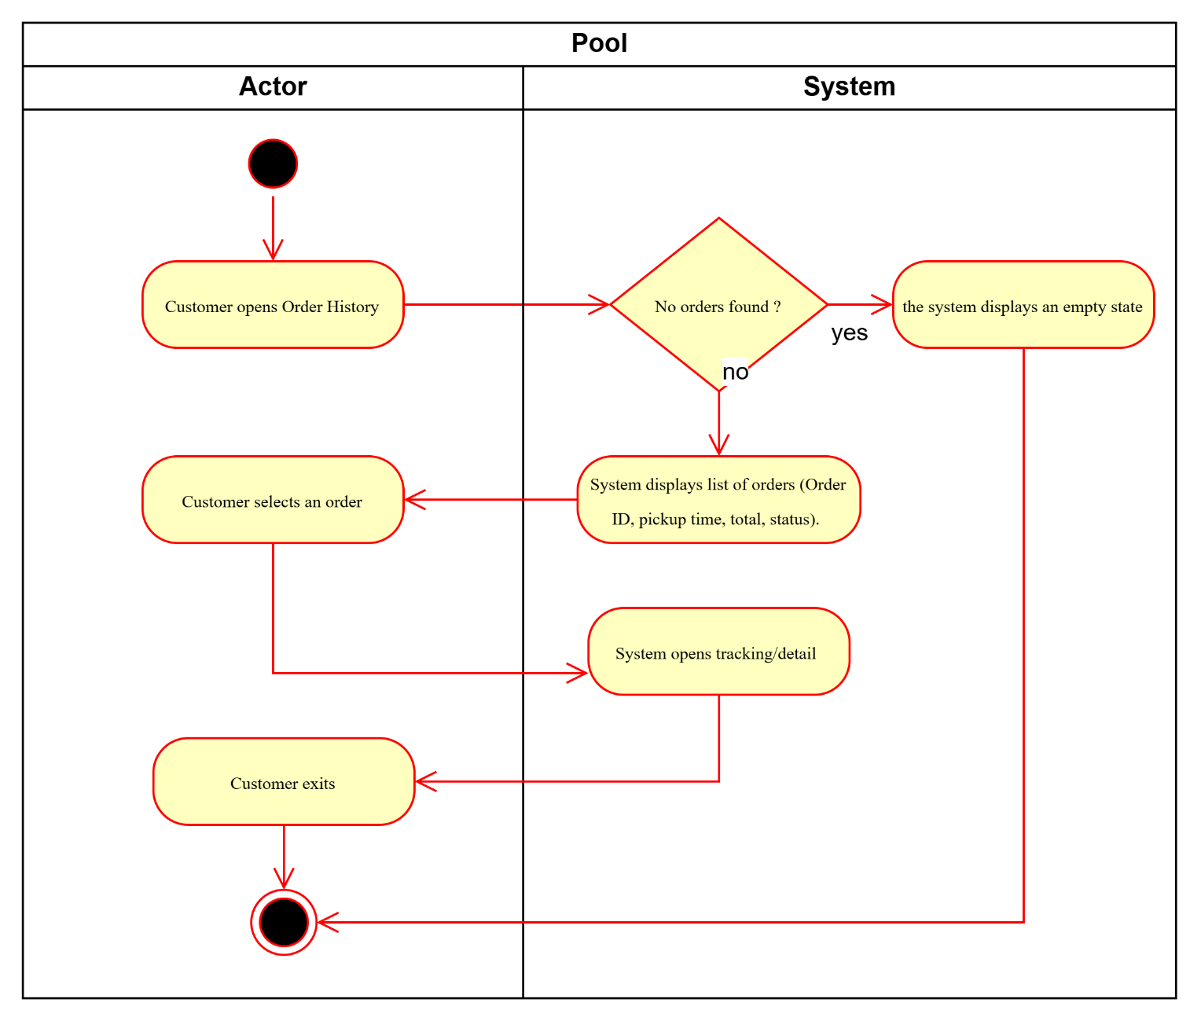

UC11- View Order Queue by Status

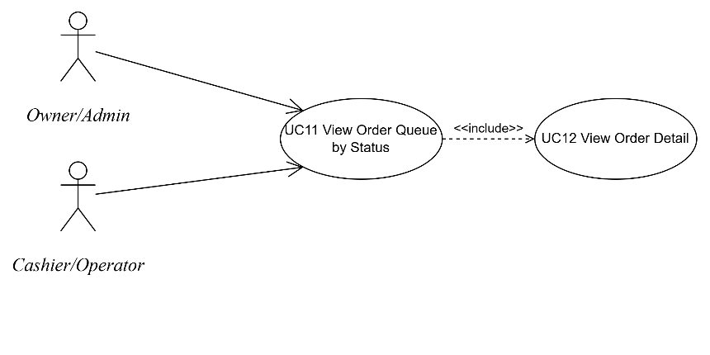
Use Case Number: | UC11
Use Case Name: | View Order Queue by Status
Actor (s): | Cashier/Operator; Owner/Admin
Maturity: | Focused
Summary: | Staff view orders grouped by status tabs for fast processing.
Basic Course of Events: | Actor Action | System Response
Basic Course of Events: | 1. Staff opens Order Queue.
Basic Course of Events: |  | 2. System displays status tabs ( Placed/Confirmed/Preparing/Ready/  Completed/Cancelled). E1
Basic Course of Events: | 3. Staff selects a status tab.
Basic Course of Events: |  | 4. System displays orders with key fields (pickupTime, orderId, item count, customer phone). E2
Basic Course of Events: | 5. Staff selects an order.
Basic Course of Events: |  | 6. System opens Order Detail (UC12).
Basic Course of Events: | 7. Staff exits queue. The use case ends here.
Alternative Paths:
Exception Paths: | E1. Unauthorized access  If the staff is not authenticated, the system redirects to login. Control returns to step 1.
Exception Paths: | E2. Queue load failure  If the queue cannot be loaded, the system displays an error state with Retry. Control returns to step 4.
Extension Points: | Search/sort/filter by phone/orderId/pickup time (Future)
Triggers: | New orders arrive; cashier starts shift; staff need a processing view.
Assumptions: | Queue refresh is acceptable within ≤10 seconds for MVP.
Preconditions: | Staff is logged in and authorized.
Post Conditions: | Staff can view orders grouped by status and open order detail.
Reference: Business Rules | BR-RBAC-01, BR-SEC-01, BR-PERF-01
Author(s): | Business Analyst
Date: | 2026-01-07
Activity Diagram:
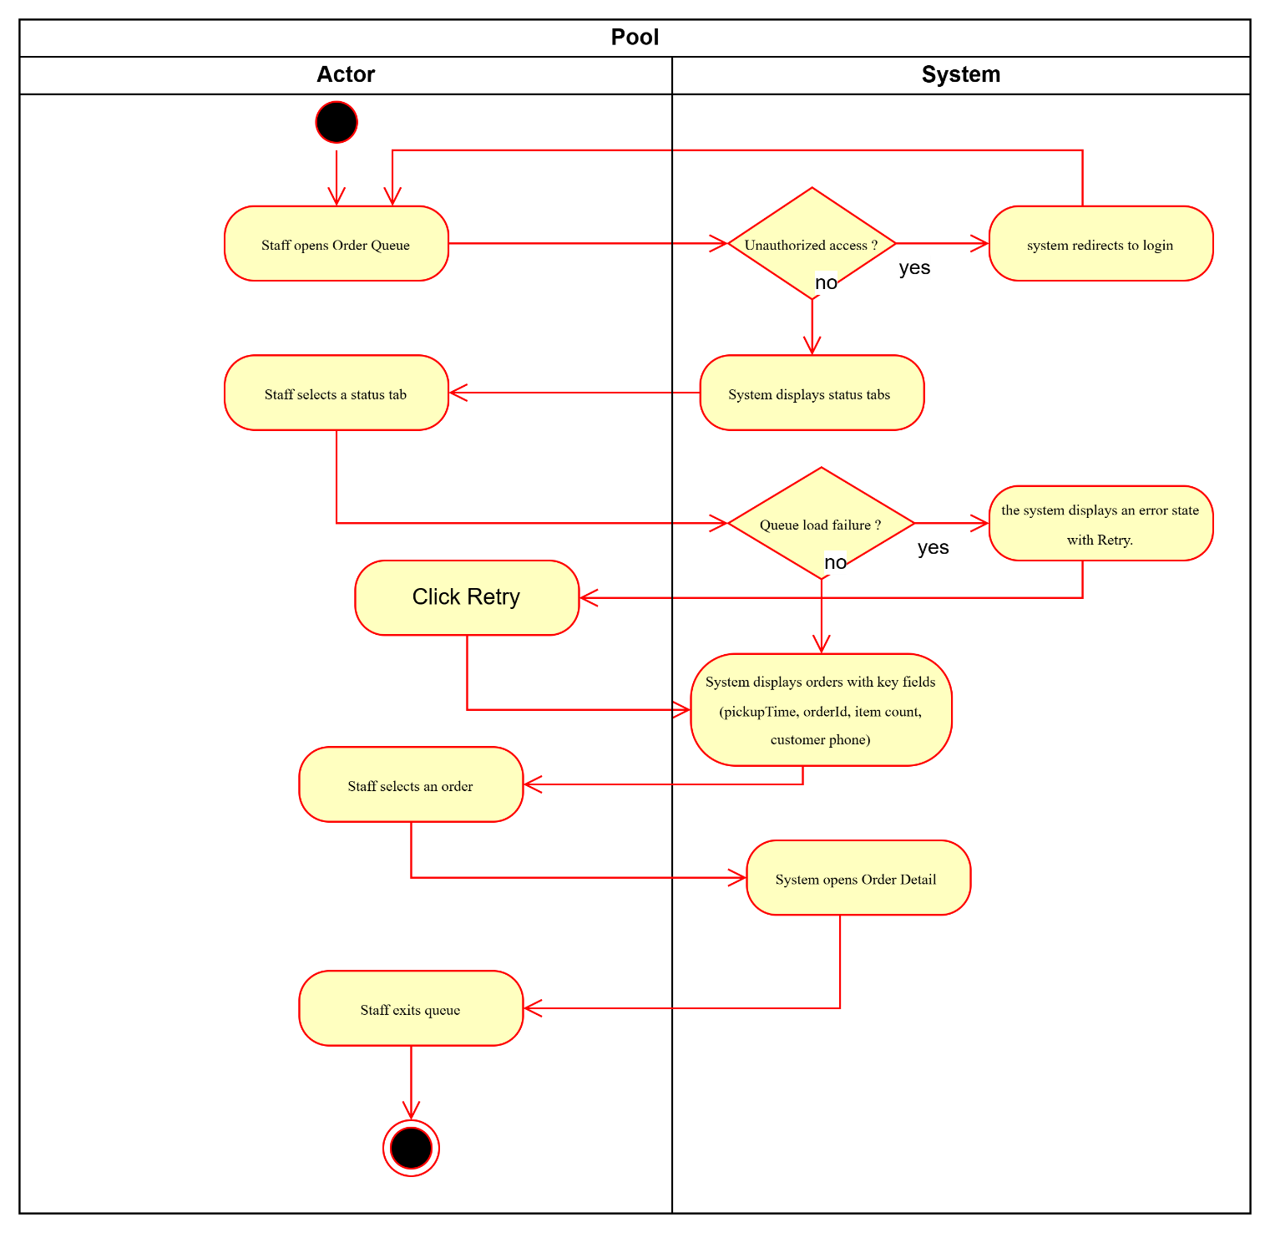

UC12- View Order Detail (Dashboard)

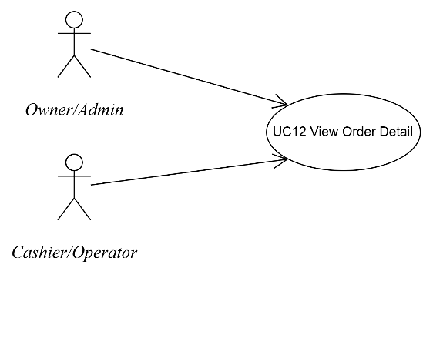
Use Case Number: | UC12
Use Case Name: | View Order Detail (Dashboard)
Actor (s): | Cashier/Operator; Owner/Admin
Maturity: | Focused
Summary: | Staff view order items, notes, pickup time, timestamps, and allowed actions by status.
Basic Course of Events: | Actor Action | System Response
Basic Course of Events: | 1. Staff selects an order from queue.
Basic Course of Events: |  | 2. System displays order detail (items, qty, notes, pickup time, phone, timestamps). E1
Basic Course of Events: |  | 3. System displays allowed actions based on status (Confirm/Reject/Update Status).
Basic Course of Events: | 4. Staff performs an allowed action.
Basic Course of Events: |  | 5. System processes the action (UC13/UC14/UC15).
Basic Course of Events: | 6. Staff exits detail. The use case ends here.
Alternative Paths:
Exception Paths: | E1. Status updated by another operator  If another operator updates the order before the page action completes, the system shows the latest status and prompts refresh. Control returns to step 1.
Extension Points: | Print kitchen ticket/order slip (Optional/Future)
Triggers: | Staff selects an order from queue to process it.
Assumptions: | Available actions depend on current status; audit log exists for status changes.
Preconditions: | Staff is logged in; order exists and is accessible by role.
Post Conditions: | Staff can view full order context and proceed with confirm/reject/status update actions.
Reference: Business Rules | BR-STAT-02, BR-AUD-01, BR-CONC-01
Author(s): | Business Analyst
Date: | 2026-01-07
Activity Diagram:
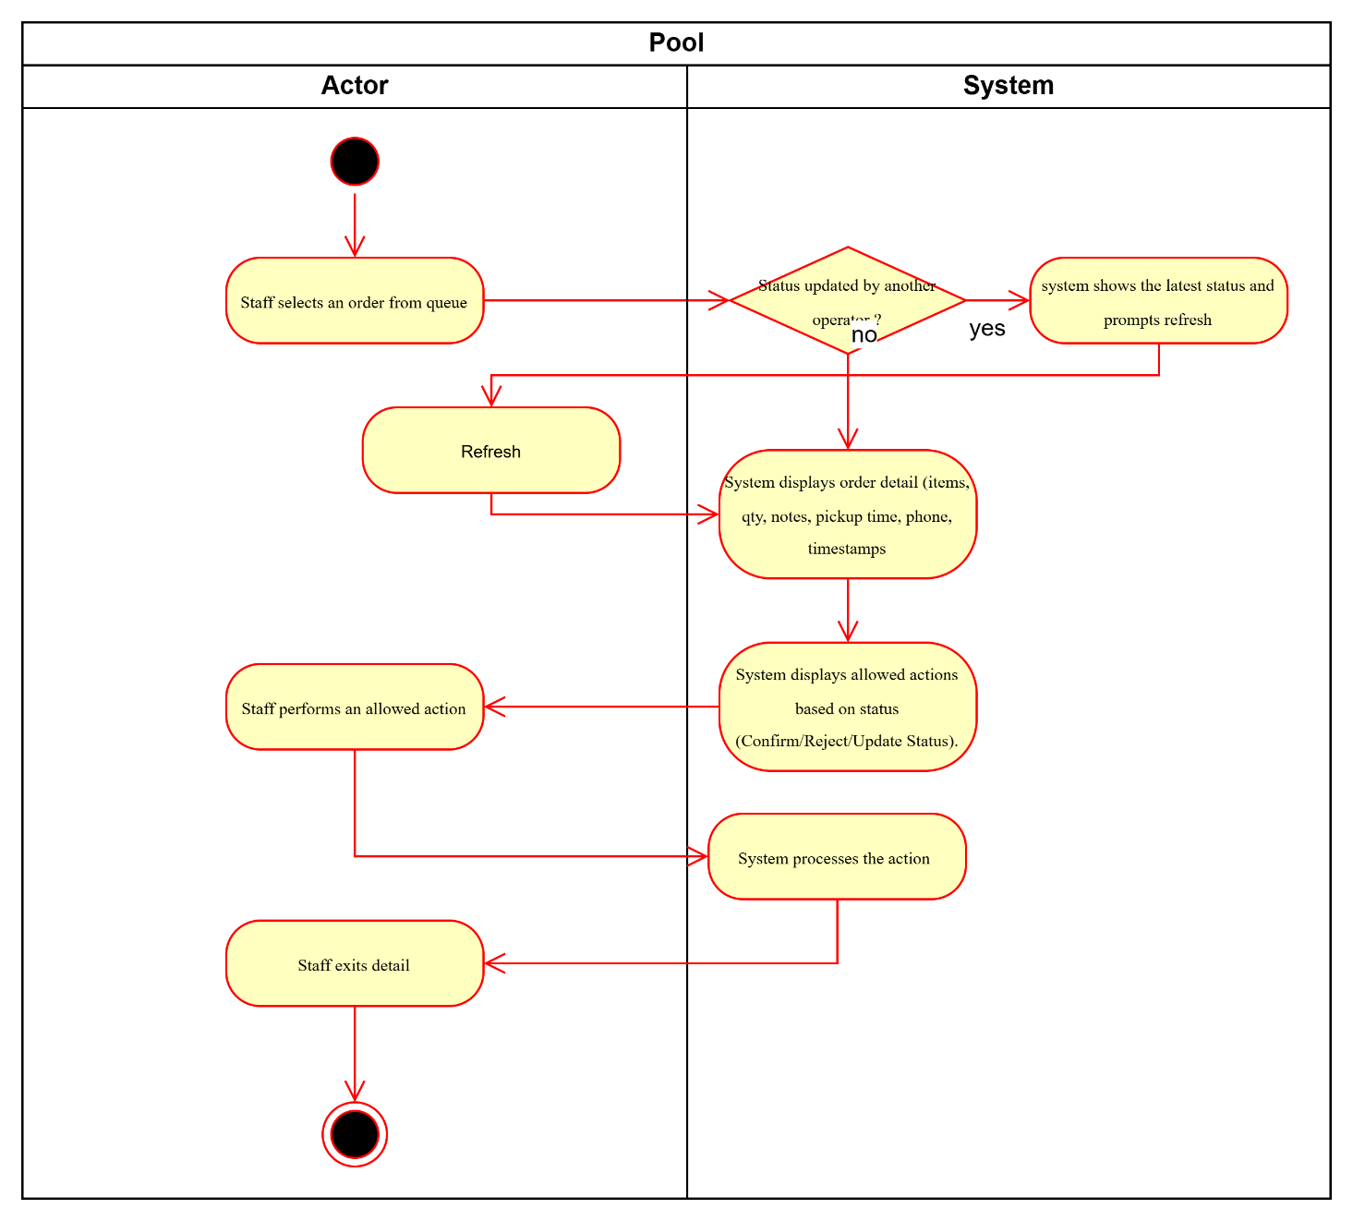

UC13- Confirm Order (Placed → Confirmed)

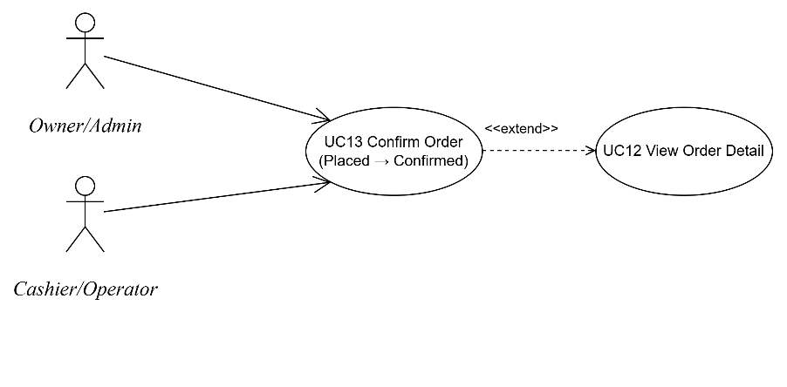
Use Case Number: | UC13
Use Case Name: | Confirm Order (Placed → Confirmed)
Actor (s): | Cashier/Operator
Maturity: | Focused
Summary: | Staff confirms a new order; system records confirmedAt and audit log.
Basic Course of Events: | Actor Action | System Response
Basic Course of Events: | 1. Staff opens Order Detail for status Placed.
Basic Course of Events: | 2. Staff clicks “Confirm”. E1, E2
Basic Course of Events: |  | 3. System transitions Placed → Confirmed, records confirmedAt, logs audit trail.
Basic Course of Events: |  | 4. System updates queue and customer tracking.
Basic Course of Events: | 5. Staff exits. The use case ends here.
Alternative Paths:
Exception Paths: | E1. Order already cancelled  If the order is already Cancelled, the system blocks confirmation and shows message. Control returns to step 1.
Exception Paths: | E2. Concurrency conflict  If another staff confirms first, the system shows “Status already updated” and blocks duplicate transition. Control returns to step 1.
Extension Points: | Set estimated ready time at confirmation (Future)
Triggers: | A new order is received in Placed status.
Assumptions: | Only staff can confirm; confirmation should be fast for handling-time KPI.
Preconditions: | Staff logged in; order status is Placed.
Post Conditions: | Order status becomes Confirmed; confirmedAt and audit record are stored; customer tracking reflects update.
Reference: Business Rules | BR-STAT-01, BR-AUD-01, BR-CONC-01
Author(s): | Business Analyst
Date: | 2026-01-07
Activity Diagram:
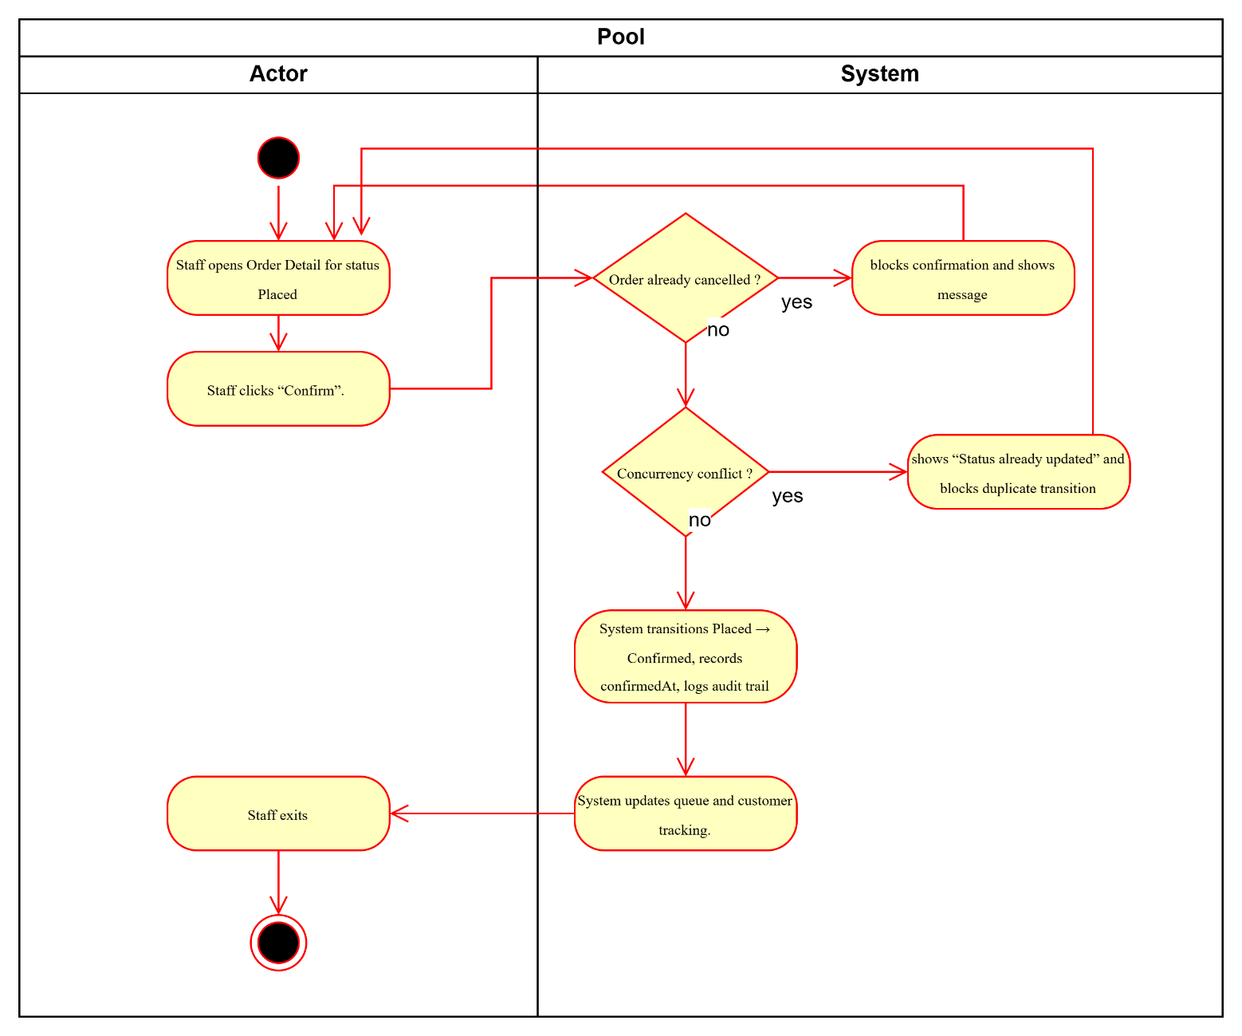

UC14- Reject Order with Reason (Placed → Cancelled)

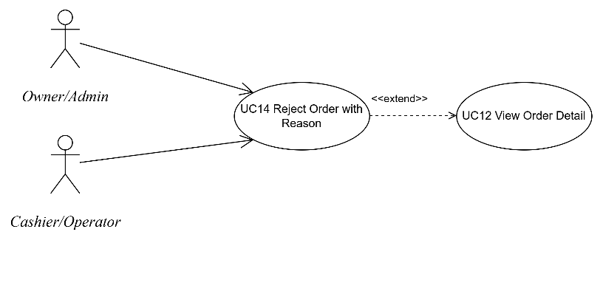
Use Case Number: | UC14
Use Case Name: | Reject Order with Reason (Placed → Cancelled)
Actor (s): | Cashier/Operator
Maturity: | Focused
Summary: | Staff rejects a Placed order with mandatory reason; customer sees Cancelled + reason.
Basic Course of Events: | Actor Action | System Response
Basic Course of Events: | 1. Staff opens Order Detail for status Placed.
Basic Course of Events: | 2. Staff clicks “Reject”.
Basic Course of Events: |  | 3. System requests a rejection reason (required). E1
Basic Course of Events: | 4. Staff enters reason and submits. E2
Basic Course of Events: |  | 5. System transitions Placed → Cancelled, stores cancelReason + cancelledAt, logs audit.
Basic Course of Events: |  | 6. System updates queue and customer tracking to show Cancelled + reason.
Basic Course of Events: | 7. Staff exits. The use case ends here.
Alternative Paths: | None
Exception Paths: | E1. Missing reason  If reason is empty, the system prompts for a reason and blocks submission. Control returns to step 3.
Exception Paths: | E2. Concurrency conflict  If another operator changes status first, the system blocks the update and shows “Status already updated”. Control returns to step 1.
Extension Points: | Preset rejection reasons + optional free text (Optional)
Triggers: | Restaurant cannot fulfill the order (out of stock/overload/cannot meet pickup time).
Assumptions: | Reason is mandatory to reduce customer confusion.
Preconditions: | Staff logged in; order status is Placed.
Post Conditions: | Order status becomes Cancelled with cancelReason; cancelledAt and audit record stored; customer sees reason in tracking.
Reference: Business Rules | BR-CAN-02, BR-AUD-01, BR-CONC-01, BR-STAT-01
Author(s): | Business Analyst
Date: | 2026-01-07
Activity Diagram:
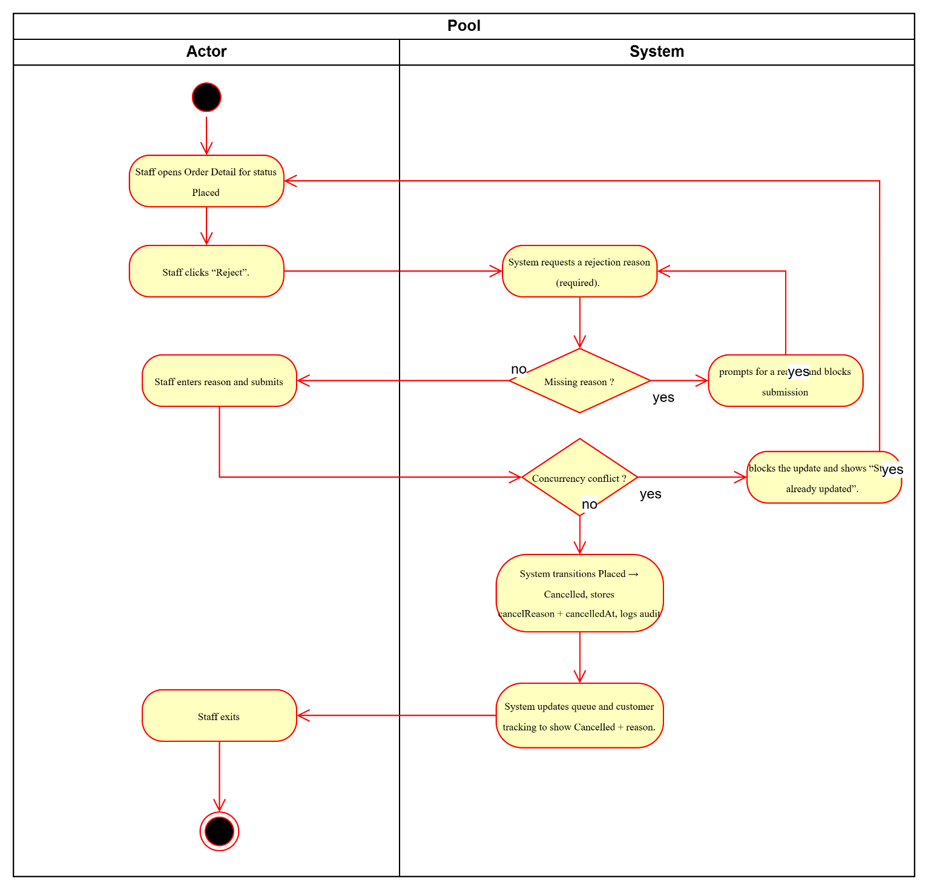

UC15- Update Order Status (Confirmed → Preparing → Ready → Completed)

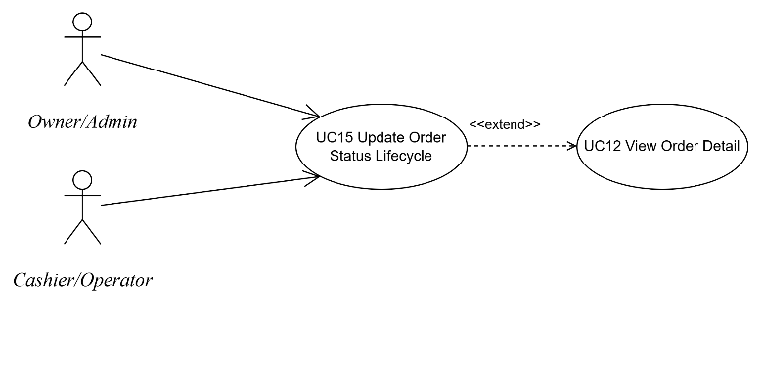
Use Case Number: | UC15
Use Case Name: | Update Order Status (Confirmed → Preparing → Ready → Completed)
Actor (s): | Cashier/Operator
Maturity: | Focused
Summary: | Staff updates order status through lifecycle; system blocks invalid transitions and records timestamps + audit.
Basic Course of Events: | Actor Action | System Response
Basic Course of Events: | 1. Staff opens Order Detail for a Confirmed order.
Basic Course of Events: | 2. Staff selects “Set Preparing”. E1, E2
Basic Course of Events: |  | 3. System transitions Confirmed → Preparing, records timestamp, logs audit.
Basic Course of Events: | 4. Staff selects “Set Ready”. E1, E2
Basic Course of Events: |  | 5. System transitions Preparing → Ready, records readyAt, logs audit; customer tracking shows Ready.
Basic Course of Events: | 6. Staff selects “Set Completed”. E1, E2
Basic Course of Events: |  | 7. System transitions Ready → Completed, records completedAt, logs audit.
Basic Course of Events: | 8. Staff exits. The use case ends here.
Alternative Paths:
Exception Paths: | E1. Invalid transition  If the staff attempts an invalid transition (e.g., Ready → Preparing), the system blocks the action and shows “Invalid status transition”. Control returns to the same step where the action was attempted (step 2 or 4 or 6).
Exception Paths: | E2. Concurrency conflict  If another operator updates status first, the system blocks the duplicate update and shows “Status already updated”. Control returns to step 1.
Extension Points: | - Lock order while being edited (implementation choice)  - Kitchen Display System integration (Out of scope MVP)
Triggers: | Preparation progress changes; customer pickup handover occurs.
Assumptions: | Only allowed transitions are permitted; timestamps/audit required for reporting KPIs.
Preconditions: | Staff logged in; order is in a valid prior status for the intended transition.
Post Conditions: | Order status is updated; relevant timestamp(s) and audit log are recorded; customer tracking reflects changes.
Reference: Business Rules | BR-STAT-01, BR-STAT-02, BR-AUD-01, BR-CONC-01
Author(s): | Business Analyst
Date: | 2026-01-07
Activity Diagram:
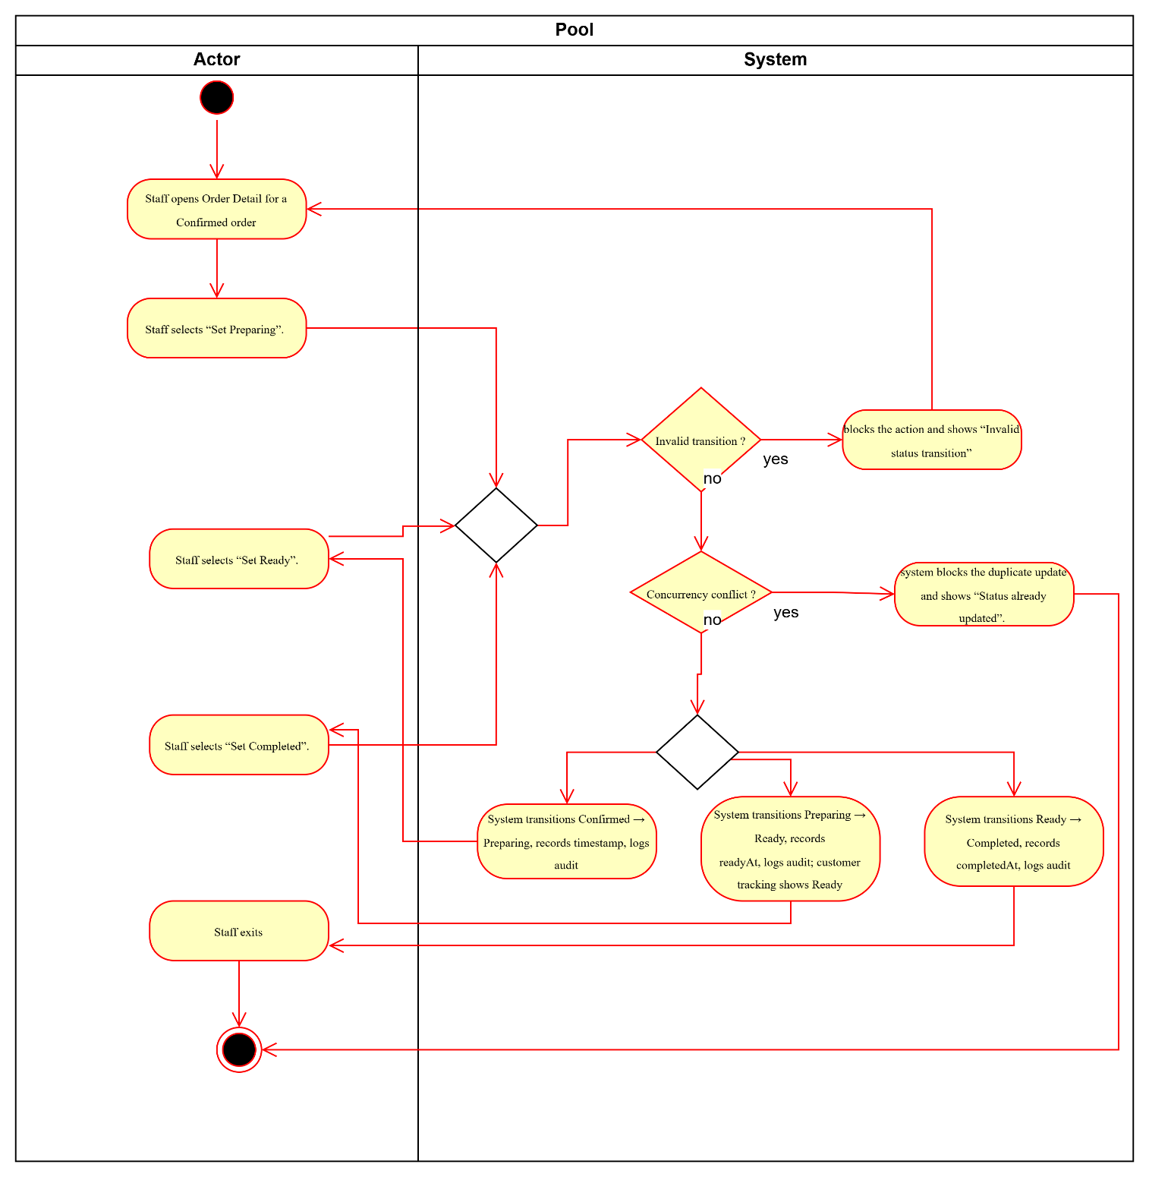

UC16- Manage Menu (CRUD Categories & Items)

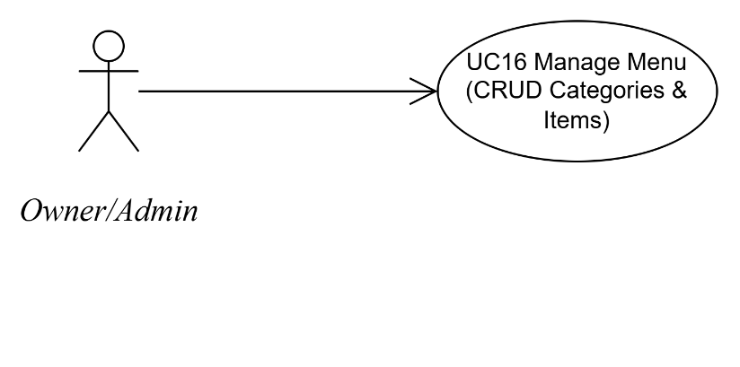
Use Case Number: | UC16
Use Case Name: | Manage Menu (CRUD Categories & Items)
Actor (s): | Owner/Admin
Maturity: | Focused
Summary: | Admin creates/edits categories and items; validates uniqueness and price rules; price snapshot protects historical totals.
Basic Course of Events: | Actor Action | System Response
Basic Course of Events: | 1. Admin opens Menu Management.
Basic Course of Events: |  | 2. System displays categories and items list.
Basic Course of Events: | 3. Admin creates a category.
Basic Course of Events: |  | 4. System validates category (non-empty, unique case-insensitive) and saves. E1
Basic Course of Events: | 5. Admin creates an item (name, price, category).
Basic Course of Events: |  | 6. System validates required fields and price > 0 and saves item. E2
Basic Course of Events: | 7. Admin creates an item (name, price, category).A1
Basic Course of Events: |  | 8. System saves changes (applies to future orders only).
Basic Course of Events: | 9. Admin exits. The use case ends here.
Alternative Paths: | A1. Edit existing item instead of creating  From step 7, the admin may select an existing item and edit fields (price/description). After saving, the system returns to the item list. Control returns to step 8.
Exception Paths: | E1. Duplicate category name  If the category name already exists (case-insensitive), the system prevents saving and shows a validation message. Control returns to step 3.
Exception Paths: | E2. Invalid price  If price ≤ 0, the system blocks saving and shows a validation message. Control returns to step 5.
Extension Points: | - Upload item image (Optional)  - Variants/toppings (Future)
Triggers: | Admin needs to create/update menu for accuracy.
Assumptions: | Category names are unique (case-insensitive); item price must be > 0.
Preconditions: | Admin logged in and authorized for menu management.
Post Conditions: | Menu is updated and reflected in customer app; historical order totals remain unchanged due to price snapshot rule.
Reference: Business Rules | BR-PRICE-01, BR-RBAC-01
Author(s): | Business Analyst
Date: | 2026-01-07
Activity Diagram:
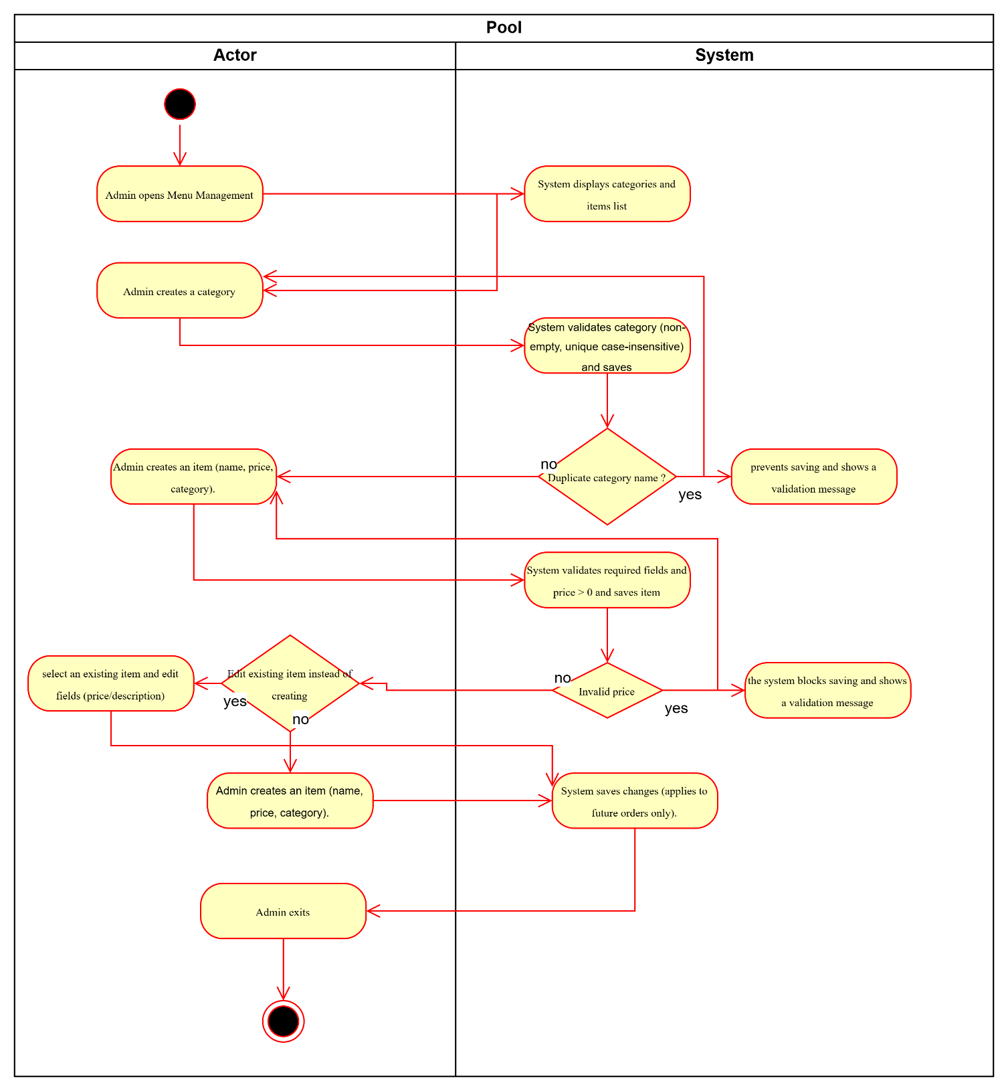

UC17- Toggle Item Availability Quickly

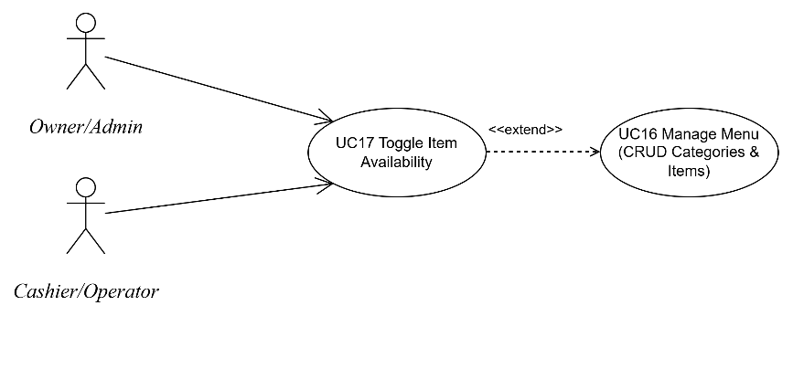
Use Case Number: | UC17
Use Case Name: | Toggle Item Availability Quickly
Actor (s): | Cashier/Operator; Owner/Admin
Maturity: | Focused
Summary: | Staff quickly toggles item availability to prevent customers from ordering out-of-stock items.
Basic Course of Events: | Actor Action | System Response
Basic Course of Events: | 1. Staff opens item list with availability toggle.
Basic Course of Events: | 2. Staff toggles an item to Unavailable/Available. E1
Basic Course of Events: |  | 3. System saves the change and reflects it on the customer app.
Basic Course of Events: | 4. Staff exits. The use case ends here.
Alternative Paths:
Exception Paths: | E1. Save failure  If the system cannot save the change, it shows an error and reverts the toggle state. Control returns to step 2.
Extension Points: | - Bulk availability toggle (Optional/Future)  - Auto-unavailable via inventory (Future)
Triggers: | Item runs out during peak hours.
Assumptions: | Cashier/Operator is allowed to toggle availability (limited menu permission).
Preconditions: | Staff logged in; item exists.
Post Conditions: | Item availability is updated and reflected to customer app; unavailable items cannot be ordered.
Reference: Business Rules | BR-AVAIL-01, BR-RBAC-01
Author(s): | Business Analyst
Date: | 2026-01-07
Activity Diagram:
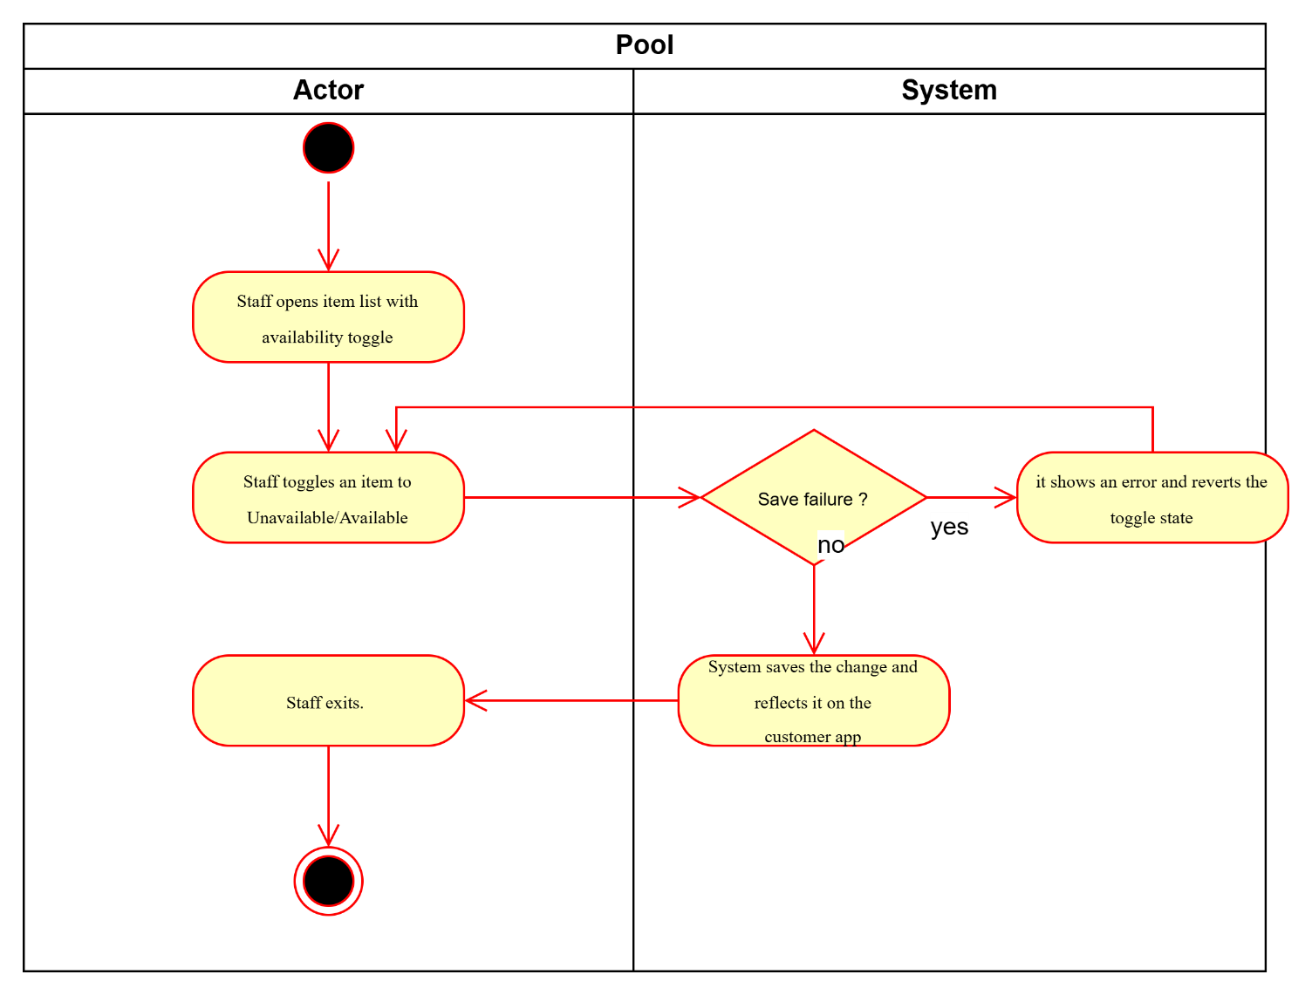

UC18- View Daily Summary Report

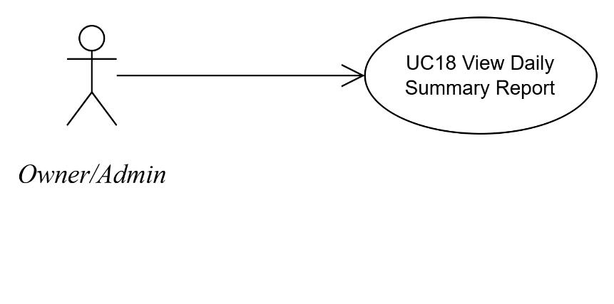
Use Case Number: | UC18
Use Case Name: | View Daily Summary Report
Actor (s): | Owner/Admin
Maturity: | Focused
Summary: | Owner views daily orders count, revenue, orders by status, and average processing time (Confirmed → Ready).
Basic Course of Events: | Actor Action | System Response
Basic Course of Events: | 1. Owner opens Reporting page.
Basic Course of Events: |  | 2. System displays date selector and “View” action.
Basic Course of Events: | 3. Owner selects a date and clicks “View”. E1, E2
Basic Course of Events: |  | 4. System displays metrics (total orders, revenue, orders by status, avg processing time).
Basic Course of Events: | 5. Owner exits. The use case ends here.
Alternative Paths:
Exception Paths: | E1. No data  If there is no data for the selected date, the system displays “No data” state. Control returns to step 2.
Exception Paths: | E2. Reporting error  If reporting fails, the system displays an error with Retry. Control returns to step 3.
Extension Points: | - Export report (CSV/PDF) (Optional)  - Peak-time distribution by pickup slot (Optional/Future)
Triggers: | Owner/Admin wants to review daily performance and KPIs.
Assumptions: | Processing time is measured primarily as Confirmed → Ready; timestamps are captured.
Preconditions: | Owner/Admin logged in and authorized for reporting.
Post Conditions: | Daily summary metrics are displayed for the selected date.
Reference: Business Rules | BR-PERF-01, BR-AUD-01
Author(s): | Business Analyst
Date: | 2026-01-07
Activity Diagram:
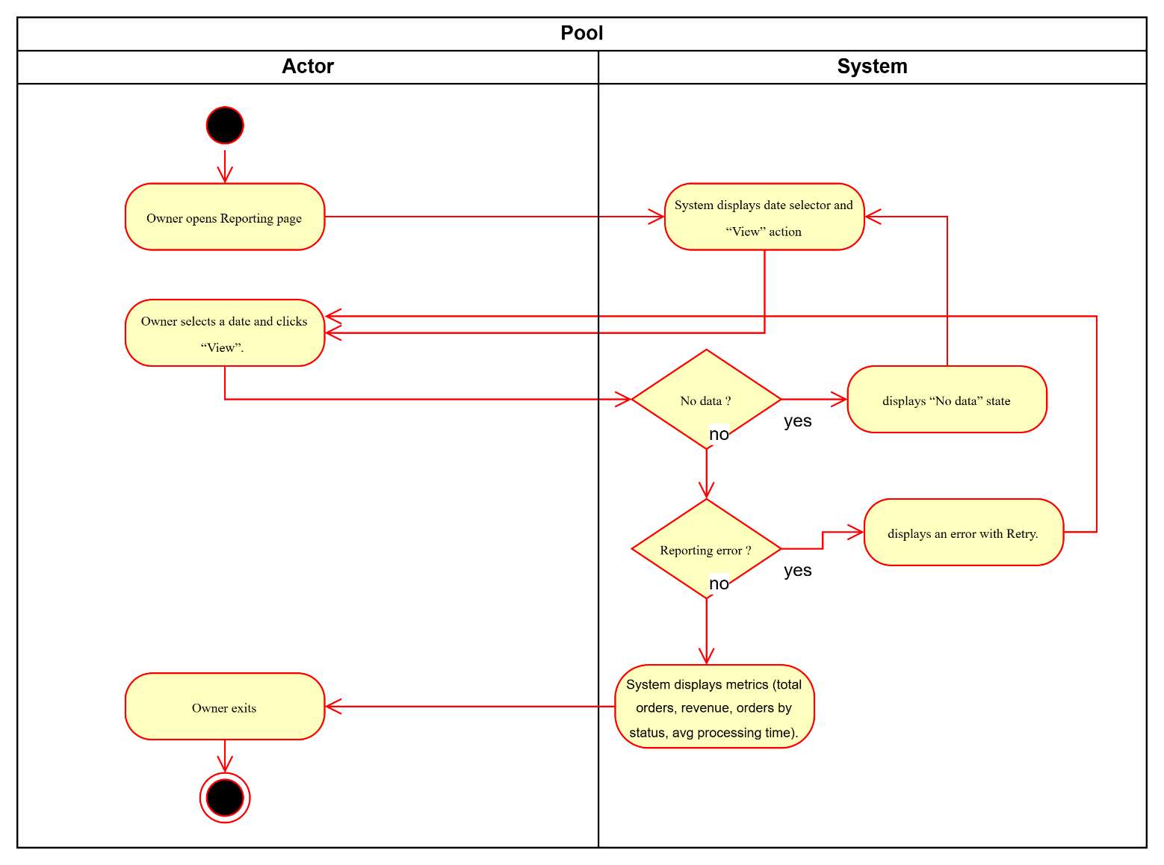

UC19- Configure Pickup Slot Settings (Minimal)

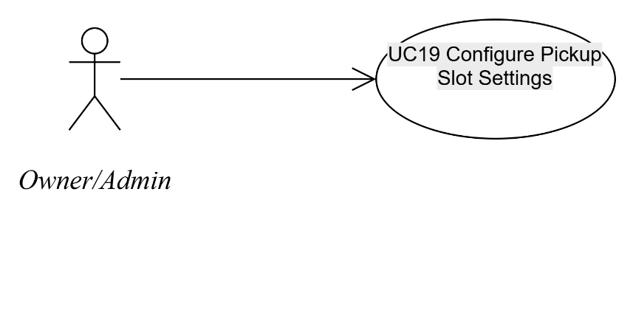
Use Case Number: | UC19
Use Case Name: | Owner/Admin
Actor (s): | Owner/Admin
Maturity: | Focused
Summary: | Admin configures pickup slot interval and optional capacity cap.
Basic Course of Events: | Actor Action | System Response
Basic Course of Events: | 1. Admin opens Settings (Minimal).
Basic Course of Events: |  | 2. System displays pickup slot interval (and capacity if enabled).
Basic Course of Events: | 3. Admin updates interval (and capacity if used) and clicks Save. E1
Basic Course of Events: |  | 4. System validates and saves configuration; applies it to slot generation.
Basic Course of Events: | 5. Admin exits. The use case ends here.
Alternative Paths:
Exception Paths: | E1. Invalid interval/capacity  If interval/capacity is invalid, the system blocks saving and shows validation error. Control returns to step 3.
Extension Points: | Different rules by day-of-week/peak hours (Future)
Triggers: | Owner/Admin needs to adjust slot interval/capacity for operational control.
Assumptions: | Settings are minimal for MVP; changes apply to future slot generation.
Preconditions: | Owner/Admin logged in; settings page available.
Post Conditions: | Slot settings are saved; customer slot list follows the updated configuration.
Reference: Business Rules | BR-SLOT-01, BR-SLOT-02
Author(s): | Business Analyst
Date: | 2026-01-07
Activity Diagram:
